CE103 Algorithms and Programming I

Introduction to Code Reusability and Automate Testing

Author: Asst. Prof. Dr. Uğur CORUH

## CE103 Algorithms and Programming I

## Week-4

#### Fall Semester, 2021-2022

Download [DOC](ce103-week-4-test.en.md_doc.pdf), [SLIDE](ce103-week-4-test.en.md_slide.pdf), [PPTX](ce103-week-4-test.en.md_slide.pptx)

## Introduction to Code Reusability and Automated Testing

During this course we will use entry level of shared library development and their tests and test automations. Also we will see TDD(Test Driven Development) approach.

During this course we will use **Windows OS, Eclipse and Visual Studio Commuity Edition** environments for examples.

Each example will include two function

“Hello ” printing function with name sayHelloTo(name) and

sum of two variable function for basic, sum = sum(a,b).

This sum function will add a to b and return result to sum variable.

We will locate them in library and use them from a console application, also we will create unit tests for testing their functionalities and return variables

## Shared Library Development

### C Programming (Static Library)

#### Visual Studio Community Edition

In this sample we will create **c-lib-sample** project that contains library, executable, unit tests and unit test runners.

First of all you install Visual Studio Community Edition from website

[Visual Studio 2019 Community Edition - Son Ücretsiz Sürümü İndir](https://visualstudio.microsoft.com/tr/vs/community/)

Open visual studio community edition and select create a new project

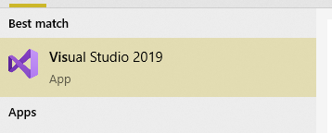

height:300px



height:500px

Select create a new project

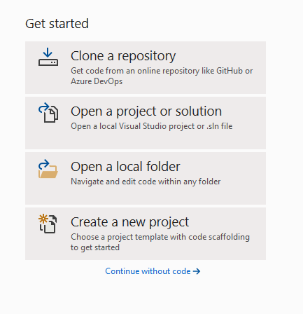

height:500px

Select C++ static library from project list

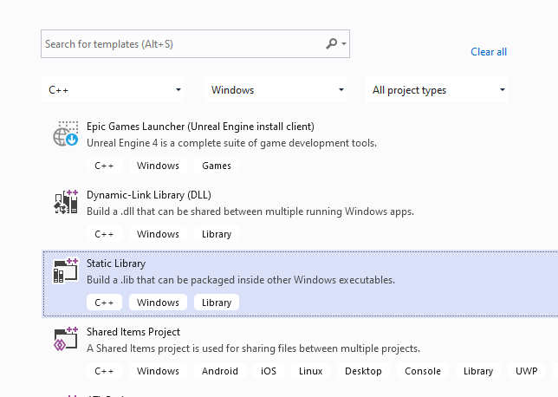

height:500px

Name static library project

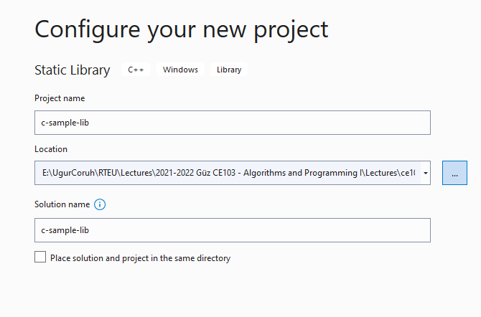

height:500px

Default configuration come with C++ project types and setting

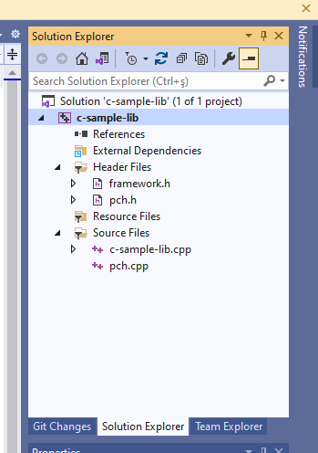

height:500px

In the c-sample-lib.cpp you will sample function

void fncsamplelib()  
{  
  
}

Delete pch.h and pch.c files. Also disable use precompiled header settings from configurations and change to “Not Using Precomplied Headers”, also you can delete precomplied Header File.

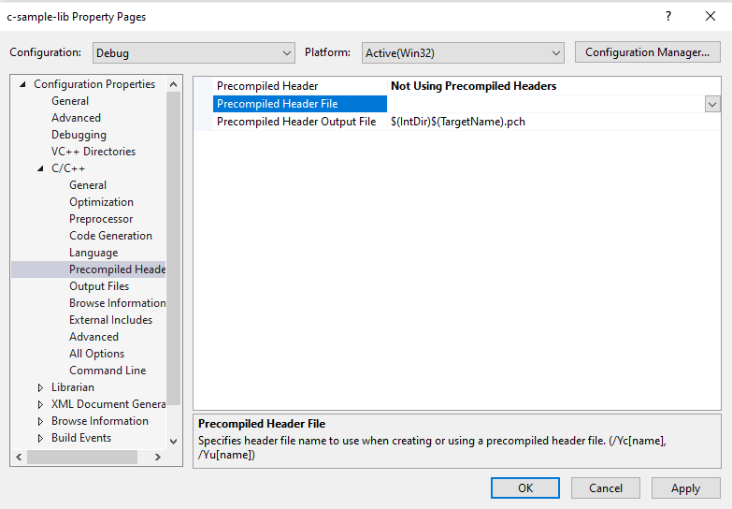

height:400px

Customize library header name and update “framework.h” to “samplelib.h”

Insert your functions inside the c-sample-lib.c and update header files also.

// c-sample-lib.cpp : Defines the functions for the static library.  
//  
  
#include "samplelib.h"  
#include "stdio.h"  
  
/// <summary>  
///   
/// </summary>  
/// <param name="name"></param>  
void sayHelloTo(char* name){  
  
 if (name != NULL){  
 printf("Hello %s \n",name);  
 }  
 else {  
 printf("Hello There\n");  
 }  
}  
  
/// <summary>  
///   
/// </summary>  
/// <param name="a"></param>  
/// <param name="b"></param>  
/// <returns></returns>  
int sum(int a, int b){  
  
 int c = 0;  
 c = a + b;  
 return c;  
}

also update samplelib.h

#pragma once  
  
#define WIN32_LEAN_AND_MEAN // Exclude rarely-used stuff from Windows headers  
  
void sayHelloTo(char* name);  
int sum(int a, int b);

If you check configuration you will see that for C complier we are using Microsoft Environment and Toolkits

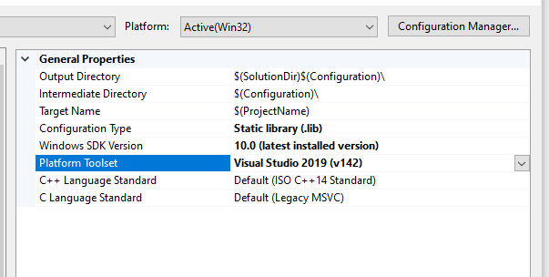

height:500px

Now we can compile our library

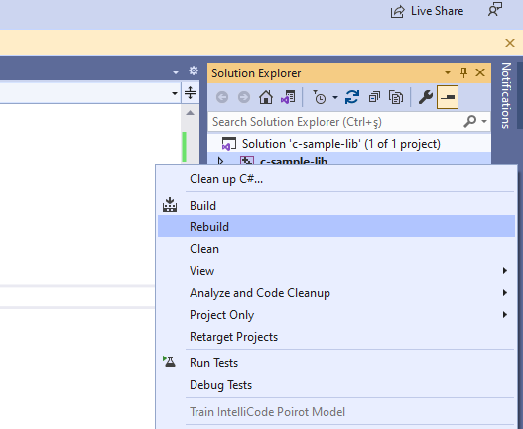

height:500px

You can follow operation from output window

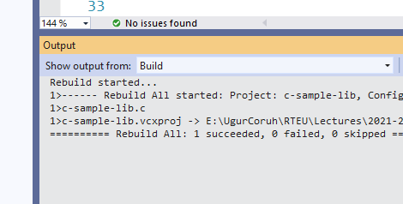

height:500px

in debug folder we will see our output

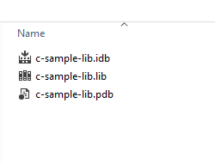

height:500px

now we will add a console application c-sample-app and use our library

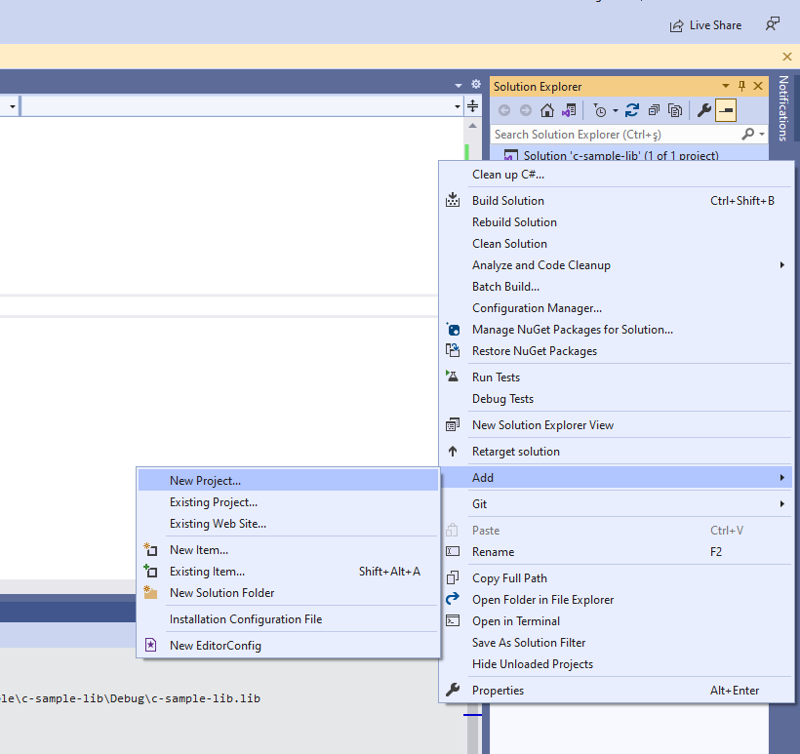

height:500px

select C++ Windows Console Application from list

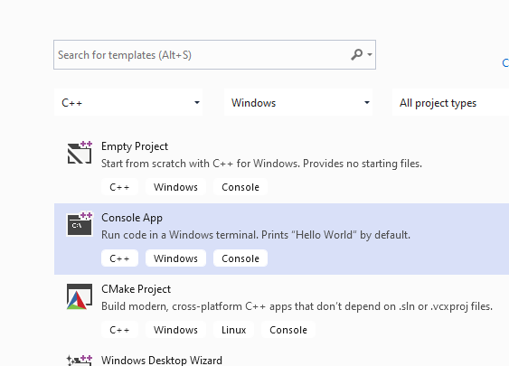

height:500px

C++ Console Application Selection will generate a C++ console project we can change extension to C to compile our application as C application.

we will convert c-sample-app.c to following code

#include <stdio.h>  
  
/// <summary>  
///   
/// </summary>  
/// <returns></returns>  
int main()  
{  
 printf("Hello World!\n");  
}

after conversion set c-sample-app as startup project and build it

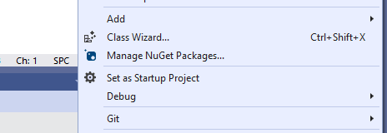

height:150px

this will create c-sample-app.exe in the same folder with c-sample-lib.lib library

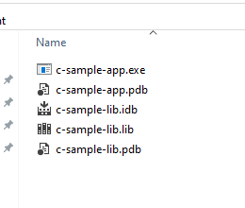

height:300px

if we run application we will see only   “Hello World”

now we will see two options to add library as references in our application and use its functions.

First option

right click references for c-sample-app and add current library as reference

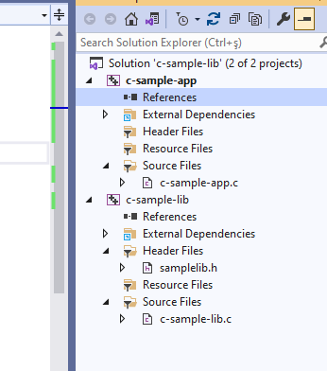

height:500px

Select Add Reference

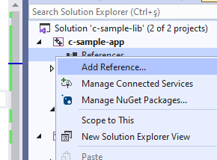

height:500px

Browse for solution and select c-sample-lib

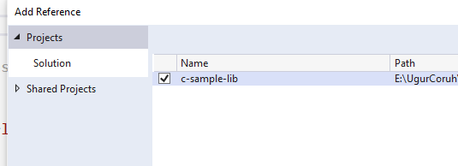

height:500px

You can check added reference from references section

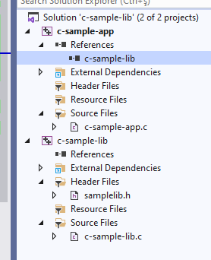

height:500px

now we can include required headers from c-sample-lib folder and use it.

we can include required header with relative path as follow or with configuration

#include <stdio.h>  
#include "..\c-sample-lib\samplelib.h"  
/// <summary>  
///   
/// </summary>  
/// <returns></returns>  
int main()  
{  
 printf("Hello World!\n");  
}

we can build our c-sample-app

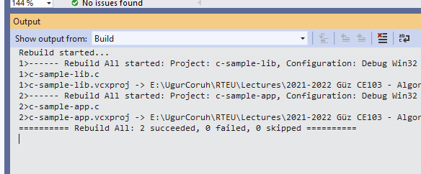

height:500px

also we can only write header name

#include <samplelib.h>

for this we need to configure include directories

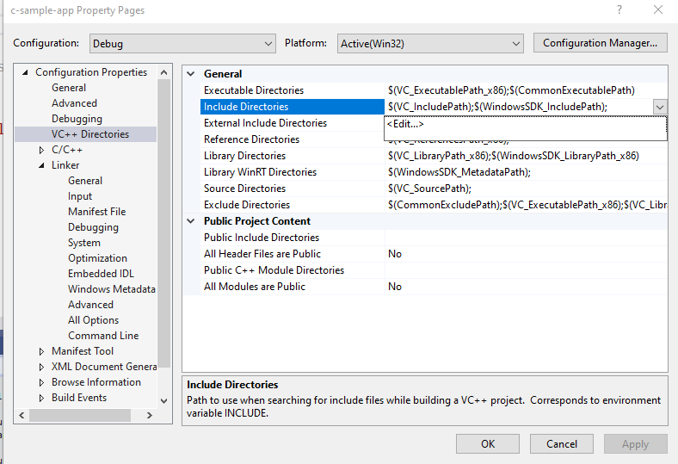

height:500px

select c-sample-lib header file location

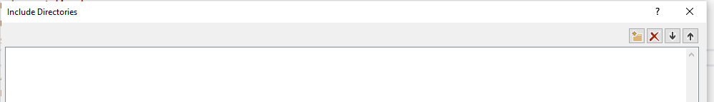

height:100px

browse for folder

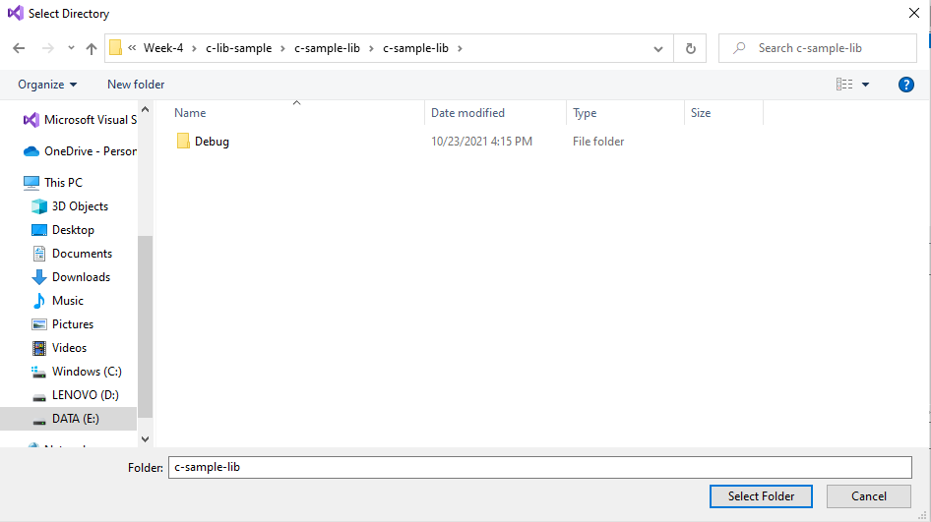

height:300px

your full path will be added to your configuration

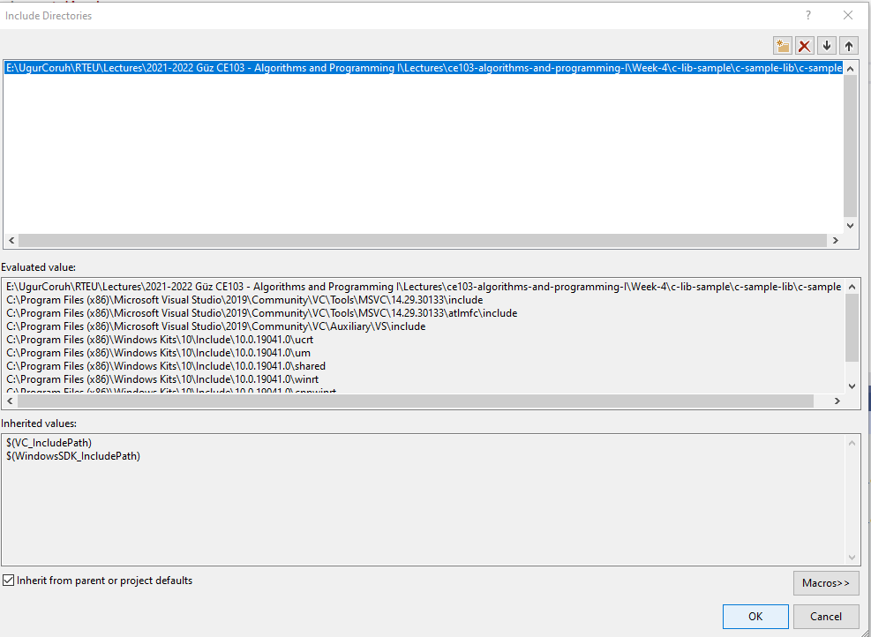

height:500px

if you add header file paths to your configuration you can use header files by name in your source code

#include <stdio.h>  
#include <samplelib.h>  
/// <summary>  
///   
/// </summary>  
/// <returns></returns>  
int main()  
{  
 printf("Hello World!\n");  
}

we can compile the following we don’t have problems but here we need to configure relative paths for configuration open include library settings and update with relative path

..\c-sample-lib

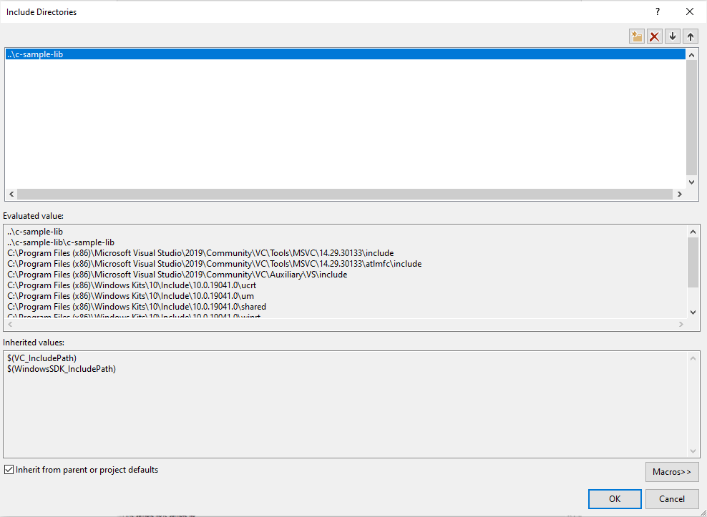

height:400px

now we have portable source code configuration. we can call our functions and then we can update header and library folder configurations.

#include <stdio.h>  
#include <samplelib.h>  
/// <summary>  
///   
/// </summary>  
/// <returns></returns>  
int main()  
{  
 int result = 0;  
 //printf("Hello World!\n");  
 result = sum(5, 4);  
 sayHelloTo("Computer");  
 printf("Result is %d \n",result);  
 printf("Press any key to continue...\n");  
 getchar();  
 return 0;  
}

when you run you will see the following outputs, that mean we called library functions.

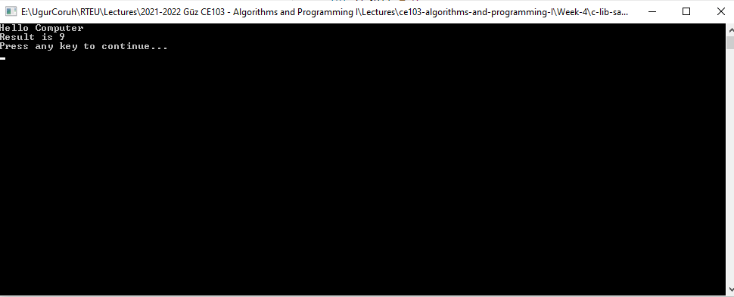

height:400px

static library is a code sharing approach if you want to share your source code with your customers then you can share static libraries and header files together. Another case you can use a precompiled static library with you or this library can be part of any installation then if there is a installed app and static libraries are placed on system folder or any different location then you can use configuration files to set library path and included header paths

Now we can remove project from c-sample-app references but we will set library file in configuration

Before this copy static library and header files to a folder like that

DebugStaticLibDeployment

* Set C/C++ -> General -> Additional Include Directories

There is a bug in configurations and relative path not finding headers so for this reason we will set full path but this is not a good practice for team working

**Not Working**

..\c-sample-lib\DebugStaticLibDeployment

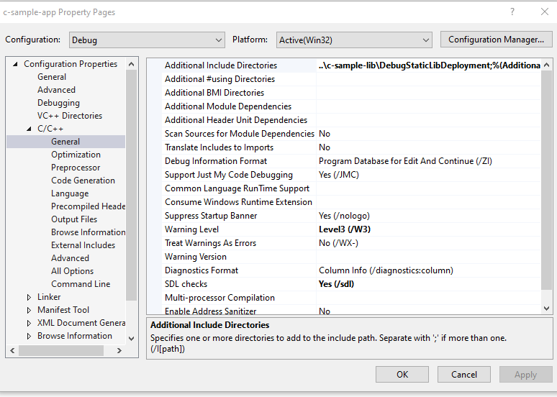

height:400px

**Working**

E:\...\c-lib-sample\c-sample-lib\DebugStaticLibDeployment

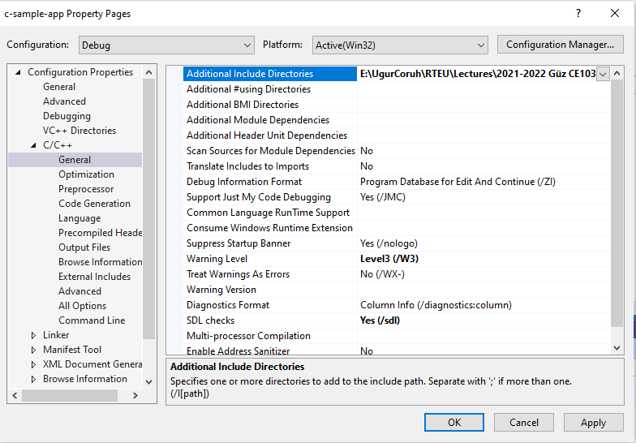

height:400px

Now we will set library folder that our static library placed

we will set VC++ Directories -> Library Directories

Here is the same issue if we use relative path it doesn’t work we need to set full path for library folder

**Working**

E:\...\c-lib-sample\c-sample-lib\DebugStaticLibDeployment

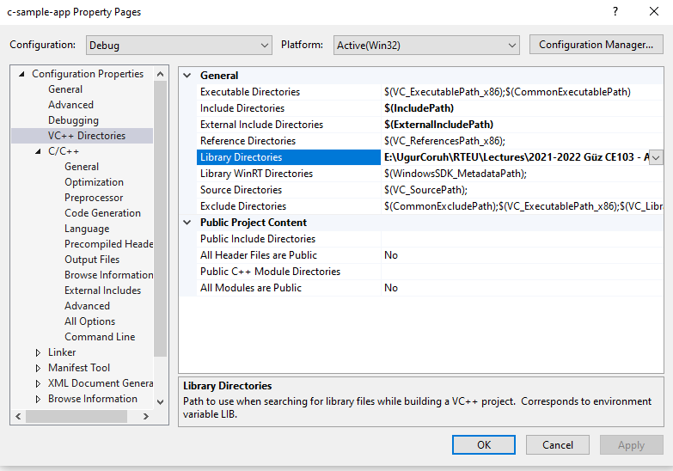

height:500px

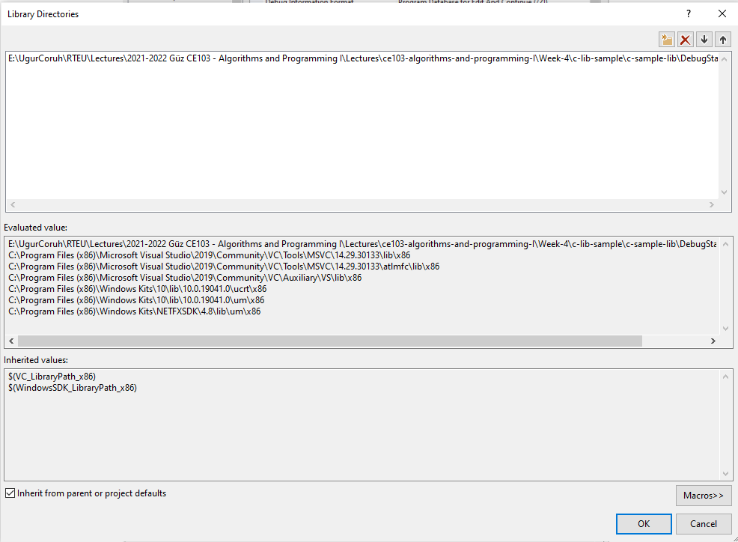

height:500px

**Not Working**

..\c-sample-lib\DebugStaticLibDeployment

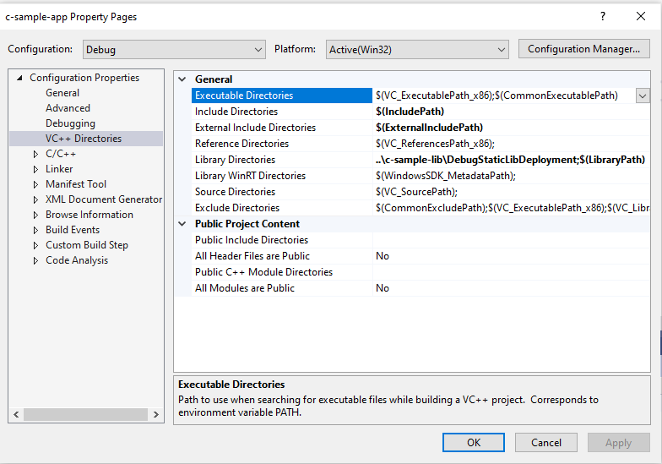

height:500px

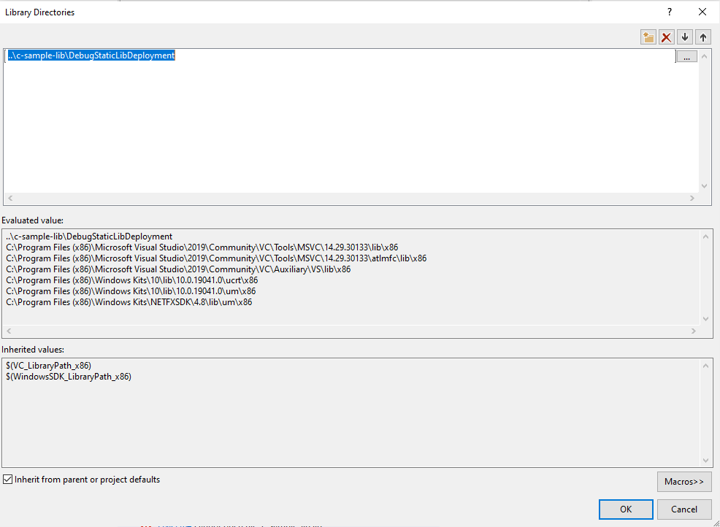

height:400px

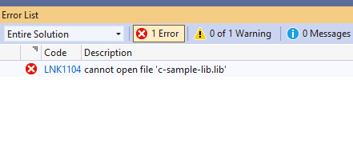

height:150px

If we set full path for both libraries and headers then we need to set library name for project

**Linker->Input->Additional Dependencies**

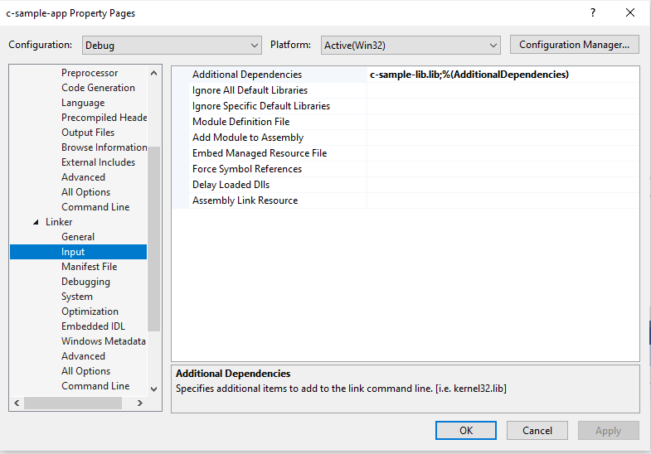

height:350px

In this case we will compile c-sample-app and we do not need to compile c-sample-lib because we copied output files to different location and they are ready to use.

current source code will be like that nothing changed

#include <stdio.h>  
#include <samplelib.h>  
  
/// <summary>  
///   
/// </summary>  
/// <returns></returns>  
int main()  
{  
 int result = 0;  
 //printf("Hello World!\n");  
 result = sum(5, 4);  
 sayHelloTo("Computer");  
 printf("Result is %d \n",result);  
 printf("Press any key to continue...\n");  
 getchar();  
 return 0;  
}

and output

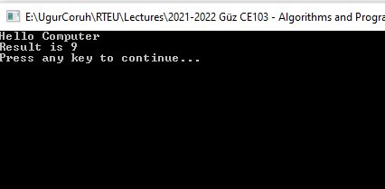

height:400px

There is a option about portability that we can set for team works

We will remove all library related settings from configurations and we will write them in source code

Clear linker->general->additional library directories

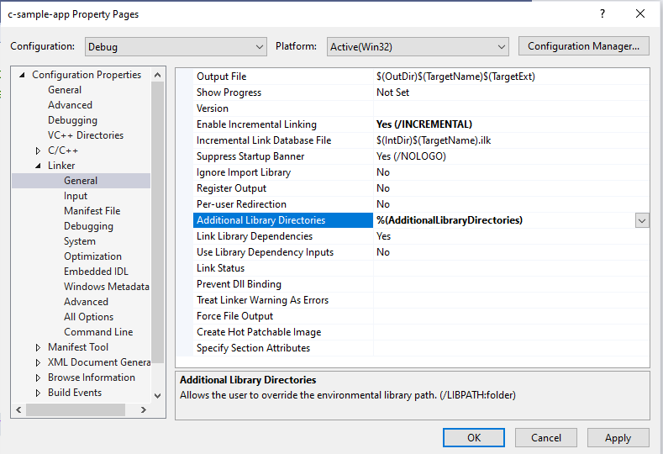

height:400px

Clear C/C++ -> General -> Additional Include Directories

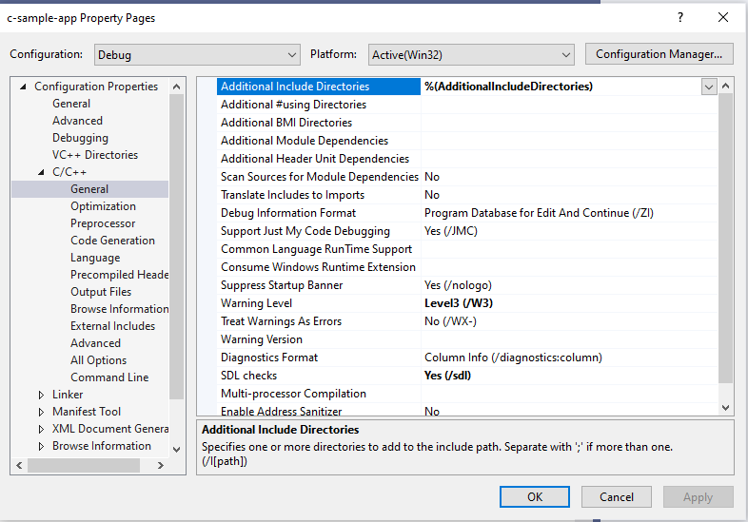

height:400px

Clear Linker->Input->Additional Dependencies

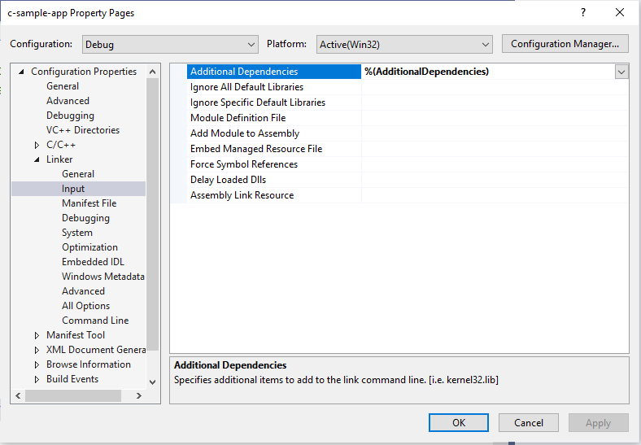

height:400px

Now we can set this configurations in source code as follow

#pragma comment(lib, "..\\DebugStaticLibDeployment\\c-sample-lib.lib")  
#include "..\DebugStaticLibDeployment\samplelib.h"  
  
#include <stdio.h>  
  
/// <summary>  
///   
/// </summary>  
/// <returns></returns>  
int main()  
{  
 int result = 0;  
 //printf("Hello World!\n");  
 result = sum(5, 4);  
 sayHelloTo("Computer");  
 printf("Result is %d \n",result);  
 printf("Press any key to continue...\n");  
 getchar();  
 return 0;  
}

with this configuration if your friends download this code then they can run them with their environment without setting a path.

### C++ Programming (Static Library)

#### Visual Studio Community Edition

All steps are similar with C programming above, but you do not need to delete pch.h

You should take care about compiled source codes

for example if your code is compiled for x86 then your application also should use the x86 configuration else x64 then library should be x64 complied version.

Source will look like the following

// cpp-sample-app.cpp : This file contains the 'main' function. Program execution begins and ends there.  
//  
  
#pragma comment(lib, "..\\DebugStaticLibDeployment\\cpp-sample-lib.lib")  
  
#include "..\DebugStaticLibDeployment\samplelib.h"  
  
#include <iostream>  
  
int main()  
{  
 std::cout << "Hello World!\n";  
  
 int result = 0;  
 //printf("Hello World!\n");  
 result = sum(5, 4);  
 sayHelloTo("Computer");  
 printf("Result is %d \n", result);  
 printf("Press any key to continue...\n");  
 getchar();  
 return 0;  
  
}

### C/C++ WSL Option

Install WSL

[GitHub - ucoruh/ns3-wsl-win10-setup: ns3 windows 10 WSL2 setup and usage](https://github.com/ucoruh/ns3-wsl-win10-setup)

Create a Linux project

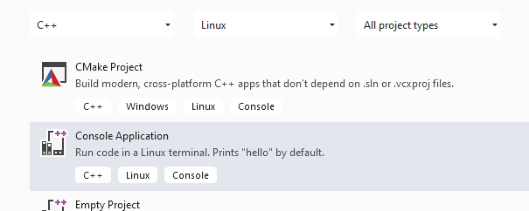

height:500px

Configure Platform Toolset to WSL

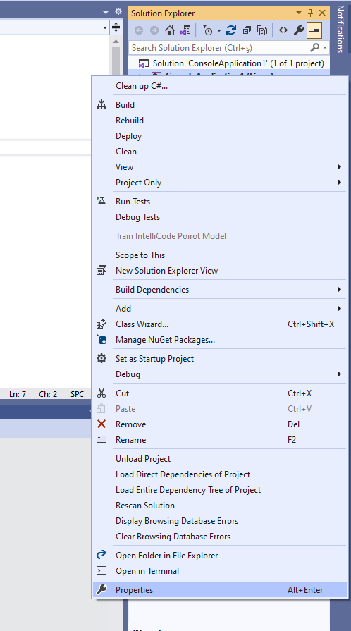

height:500px

Select GCC for Windows Subsystem for Linux

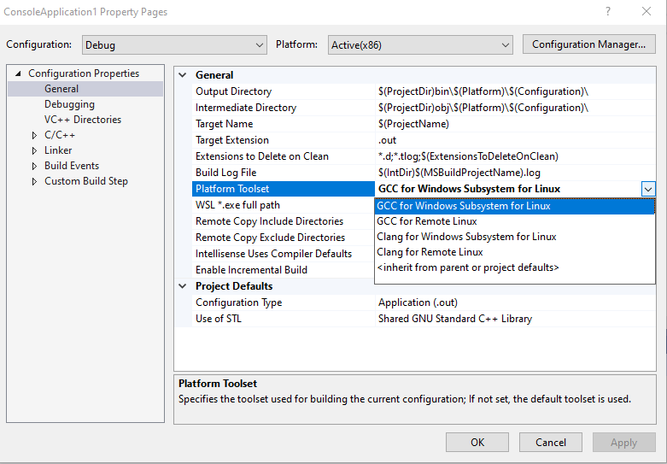

height:400px

Put a breakpoint and run debugger

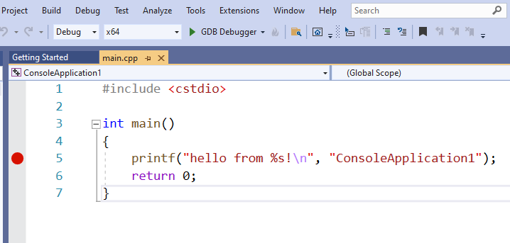

height:400px

In the debugger for WSL you can use local WSL installation but if you want to run it on Release setting it require a SSH connection.

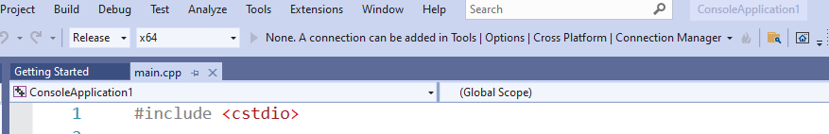

height:200px

Configure SSH parameters

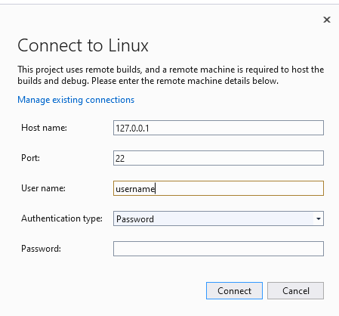

height:400px

so you have to complete the following steps.

### C/C++ Remote Linux Option over SSH

Enable SSH

[SSH on Windows Subsystem for Linux (WSL) | Illuminia Studios](https://www.illuminiastudios.com/dev-diaries/ssh-on-windows-subsystem-for-linux/)

Connect to Remote WSL Environment

[Bağlan hedef Linux sisteminize Visual Studio | Microsoft Docs](https://docs.microsoft.com/tr-tr/cpp/linux/connect-to-your-remote-linux-computer?view=msvc-160)

### C# Programming (Dinamik Library)

#### Visual Studio Community Edition

In C# project we will create class library we have several options

for this sample we will select .NET core that we can build cross platform library

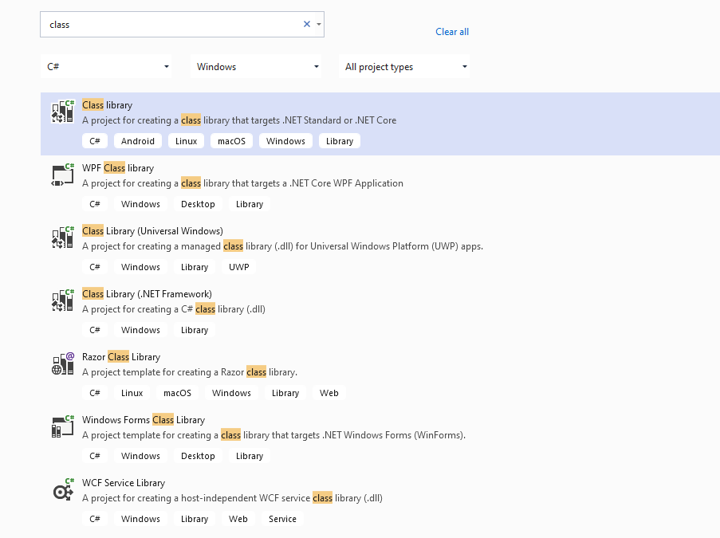

height:400px

There is no static library option

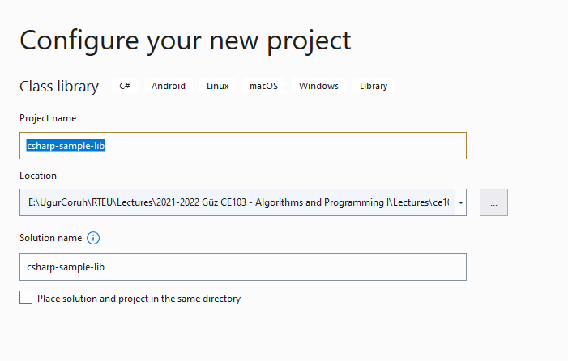

We will select .Net Core 3.1

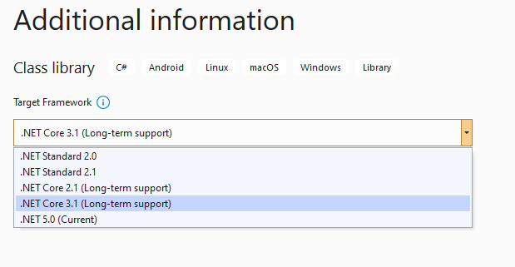

height:400px

You will have default empty class library file

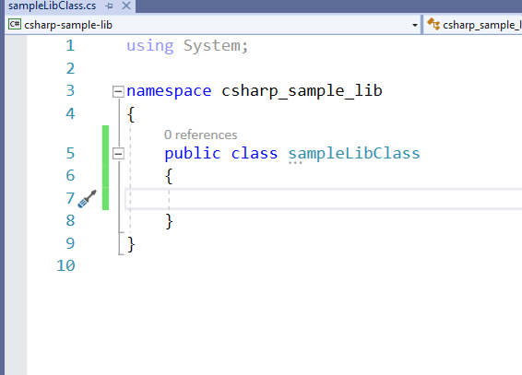

height:400px

In the project you can see .NETcore reference

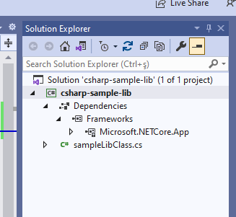

height:400px

We can build empty class library that generate dll for our application

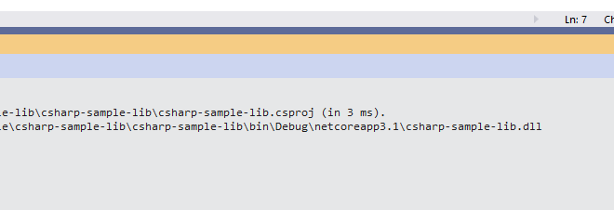

height:400px

Now we will add Console Application but this will also use .NETCore

Select New Project

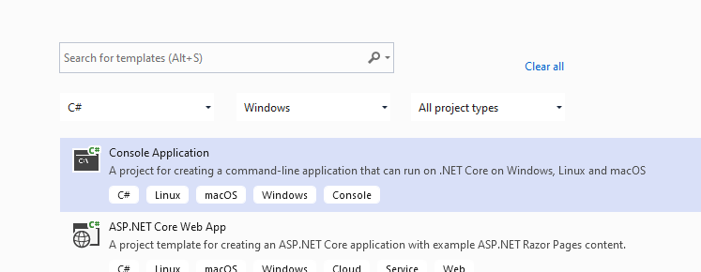

height:400px

Name the project

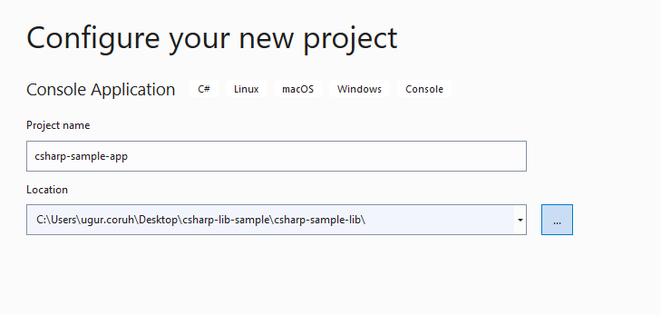

height:400px

Select .NETCore framework

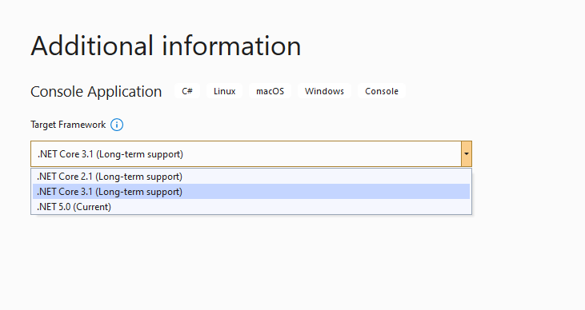

height:400px

You will have the following sample main.cs file

using System;  
  
namespace csharp_sample_app  
{  
 class Program  
 {  
 static void Main(string[] args)  
 {  
 Console.WriteLine("Hello World!");  
 }  
 }  
}

Now we can link projects with adding references open reference section

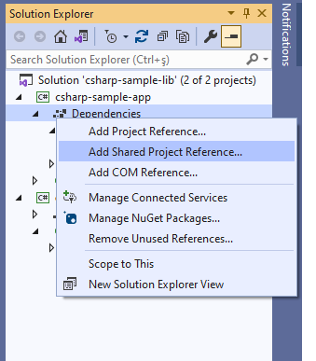

height:400px

browse for class library project output folder and select output dll file for console application

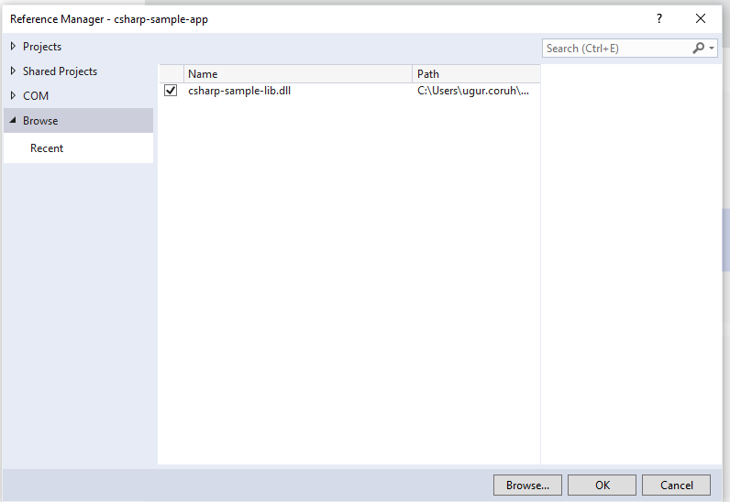

height:400px

now we can update our library code and use it in console application

copy following sample to sampleLibClass file in the library

using System;  
  
namespace csharp_sample_lib  
{  
 public class sampleLibClass  
 {  
 public static void sayHelloTo(string name)  
 {  
 if (!String.IsNullOrEmpty(name))  
 {  
 Console.WriteLine("Hello " + name);  
 }  
 else  
 {  
 Console.WriteLine("Hello There");  
 }  
  
 }  
  
 public static int sum(int a, int b)  
 {  
 int c = 0;  
 c = a + b;  
 return c;  
 }  
 }  
}

after this operation copy following sample to console application and build app then you can run

using csharp_sample_lib;  
using System;  
  
namespace csharp_sample_app  
{  
 class Program  
 {  
 static void Main(string[] args)  
 {  
 Console.WriteLine("Hello World!");  
  
 sampleLibClass.sayHelloTo("Computer");  
 int result = sampleLibClass.sum(5, 4);  
 Console.WriteLine("Results is" + result);  
 Console.WriteLine("Results is {0}", result);  
 Console.Read();  
 }  
 }  
}

You will see following output that mean we called DLL functions

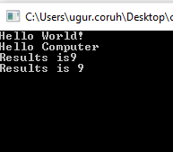

height:400px

Also we can publish this console application with dll for linux environment or others

for linux environment we should install .NETCore

follow the link below or commands that I shared with you as below for deployment

[How to Install Dotnet Core on Ubuntu 20.04 – TecAdmin](https://tecadmin.net/how-to-install-net-core-on-ubuntu-20-04/)

Step 1 – Enable Microsoft PPA

wget https://packages.microsoft.com/config/ubuntu/20.04/packages-microsoft-prod.deb   
sudo dpkg -i packages-microsoft-prod.deb

Step 2 – Installing Dotnet Core SDK

sudo apt update   
sudo apt install apt-transport-https   
sudo apt install dotnet-sdk-3.1

Step 3 – Install Dotnet Core Runtime Only

To install .NET Core Runtime on Ubuntu 20.04 LTS system, execute the commands:

sudo apt update

To install the previous version of .Net core runtime 2.1, type:

sudo apt install dotnet-runtime-2.1

Press “y” for any input prompted by the installer.

Step 4 – (Optional) Check .NET Core Version

You can use dotnet command line utility to check installed version of .NET Core on your system. To check dotnet version, type:

dotnet --version

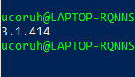

height:200px

Now we will publish our application as single executable

Open publish menu

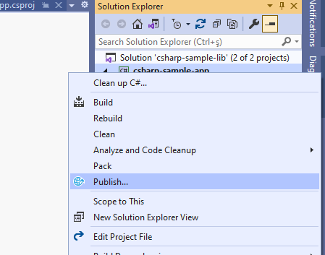

height:400px

Select netcoreapp3.1 and Release for linux-x64

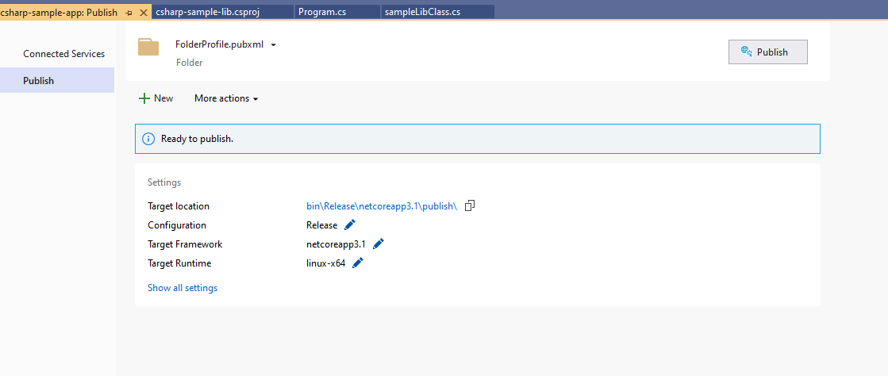

height:400px

Select produce single file

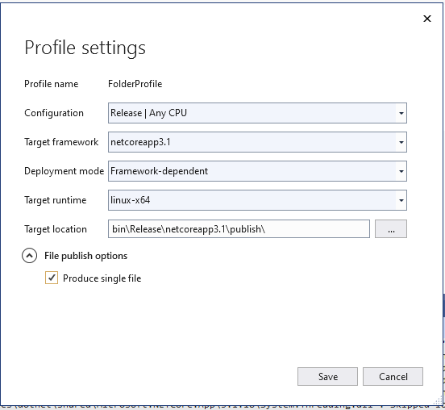

height:400px

After succesfull publish you will have linux binary that you can run with WSL

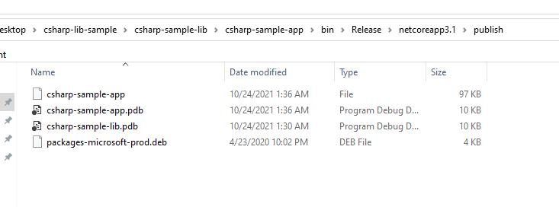

height:400px

Open WSL and enter the path where this folder located

and run application as follow

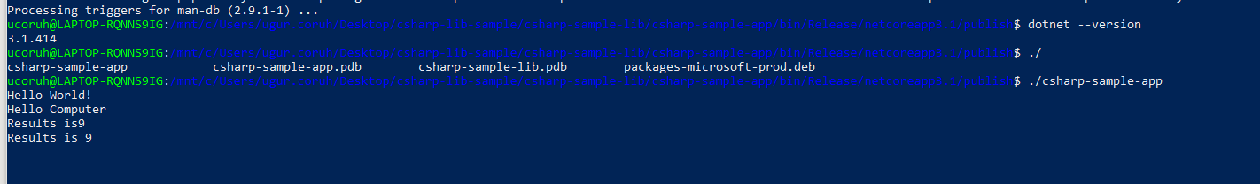

check dotnet –version and then run application

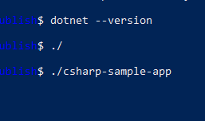

you will see similar output

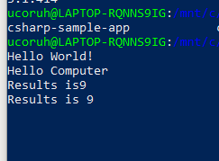

In this sample we created single application from settings lets try with shared library located option uncheck the “produce single file” option and publish again.

Then you will have the following outputs

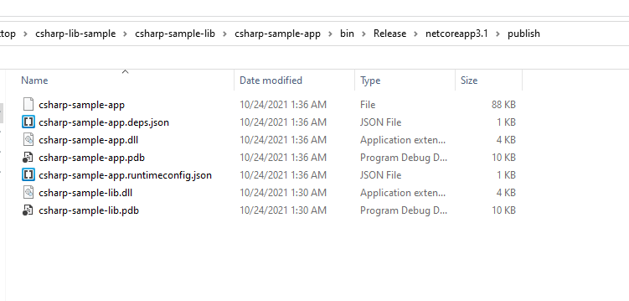

height:400px

If you run csharp-sample-app

you will have the same output

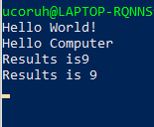

height:300px

### Java Programming

#### Eclipse IDE

You should download and install eclipse installer and then you should select Eclipse IDE for Java Developers

[Eclipse Installer 2021-09 R | Eclipse Packages](https://www.eclipse.org/downloads/packages/installer)



height:400px

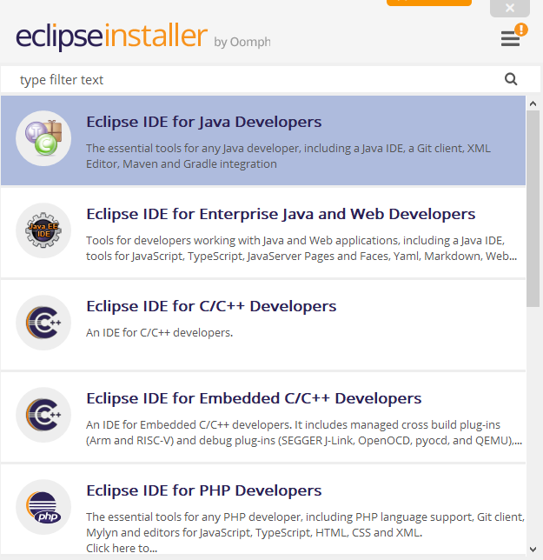

height:500px

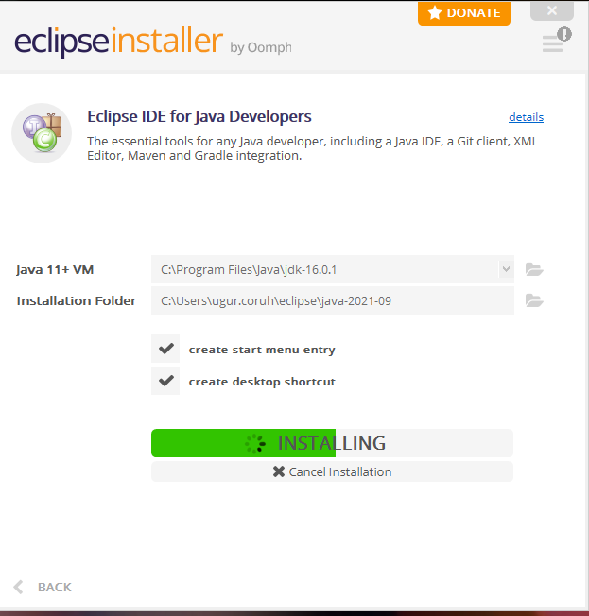

height:500px



select create a project

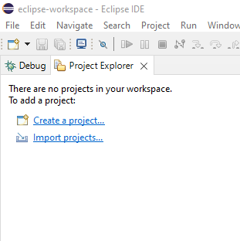

height:500px

select java project

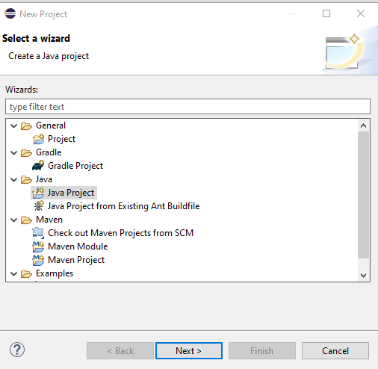

height:500px

give project name

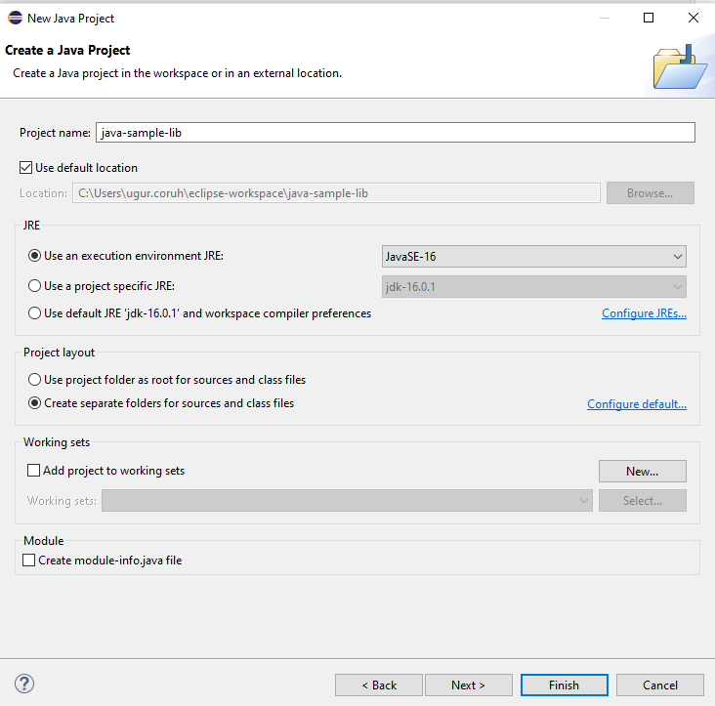

height:500px

select finish

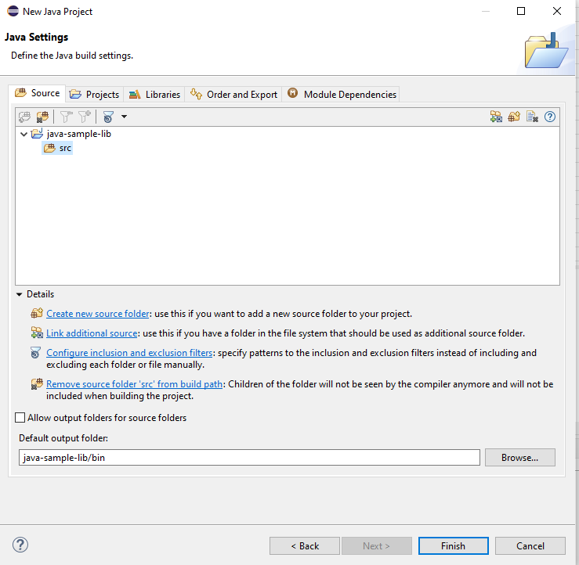

height:500px

first we need to add a default package to keep everything organized

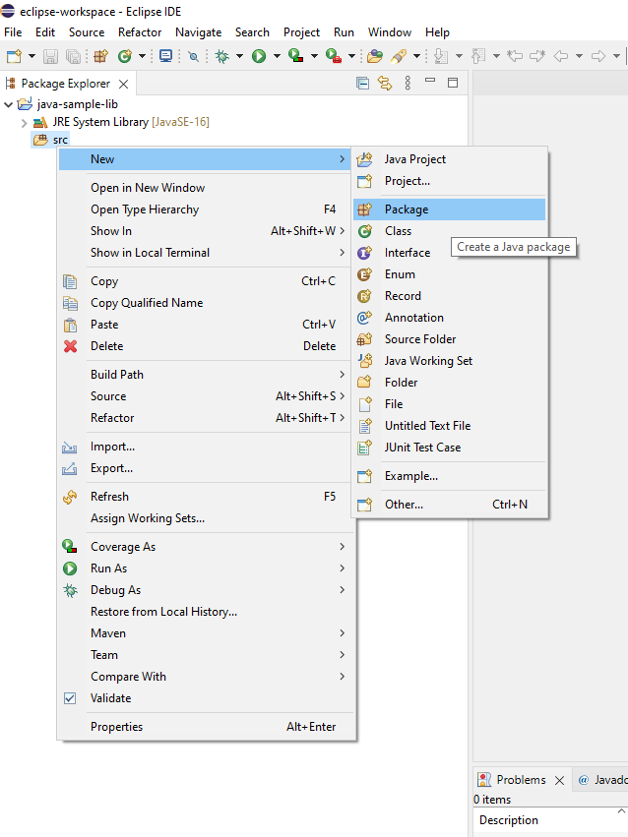

height:500px

then we can create our class that includes our functions

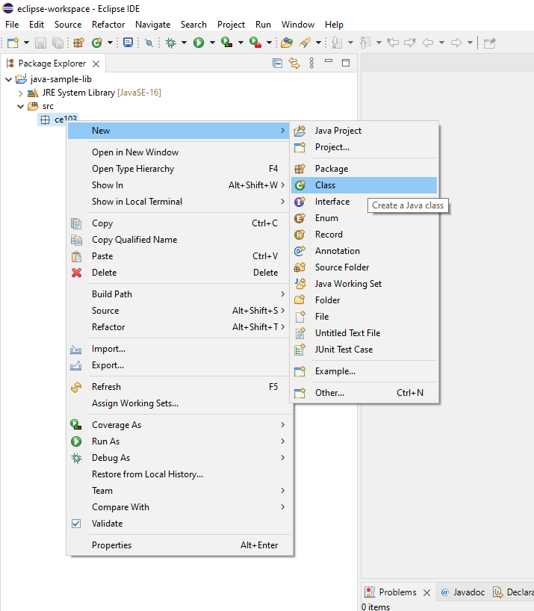

height:500px

give class a name

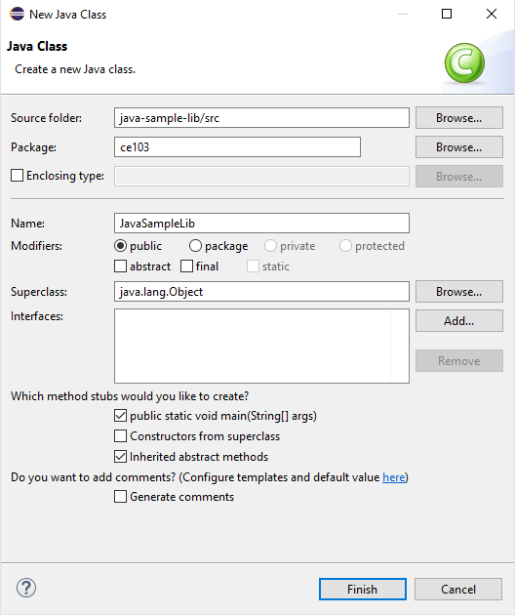

height:500px

you will have following class with main

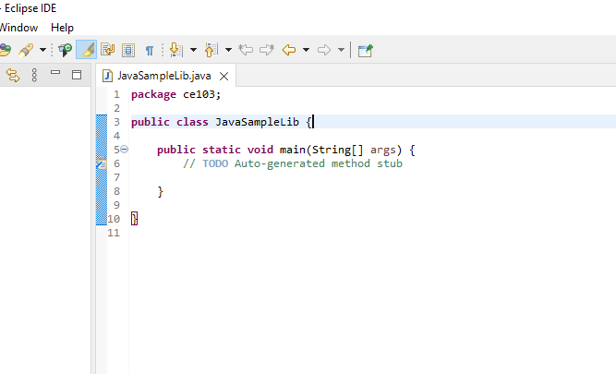

height:500px

We will create sample java library with static functions as below.

package ce103;  
  
import java.io.IOException;  
  
public class JavaSampleLib {  
  
 public static void sayHelloTo(String name) {  
 if(name.isBlank() || name.isEmpty())  
 {  
 System.out.println("Hello "+name);  
 }else {  
 System.out.println("Hello There");  
 }  
 }  
  
 public static int sum(int a,int b)  
 {  
 int c = 0;  
 c = a+b;  
 return c;  
 }  
  
 public static void main(String[] args) {  
 // TODO Auto-generated method stub  
 System.out.println("Hello World!");  
  
 JavaSampleLib.sayHelloTo("Computer");  
 int result = JavaSampleLib.sum(5, 4);  
 System.out.println("Results is" + result);  
 System.out.printf("Results is %d \n", result);  
  
  
 try {  
 System.in.read();  
 } catch (IOException e) {  
 // TODO Auto-generated catch block  
 e.printStackTrace();  
 }  
  
 }  
  
}

also we can add main method to run our library functions. If we run this file its process main function

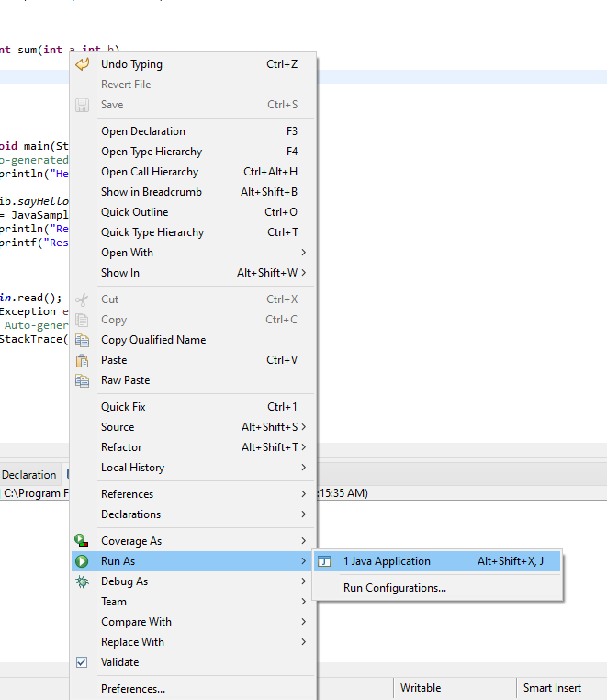

height:500px

we can see output from console as below

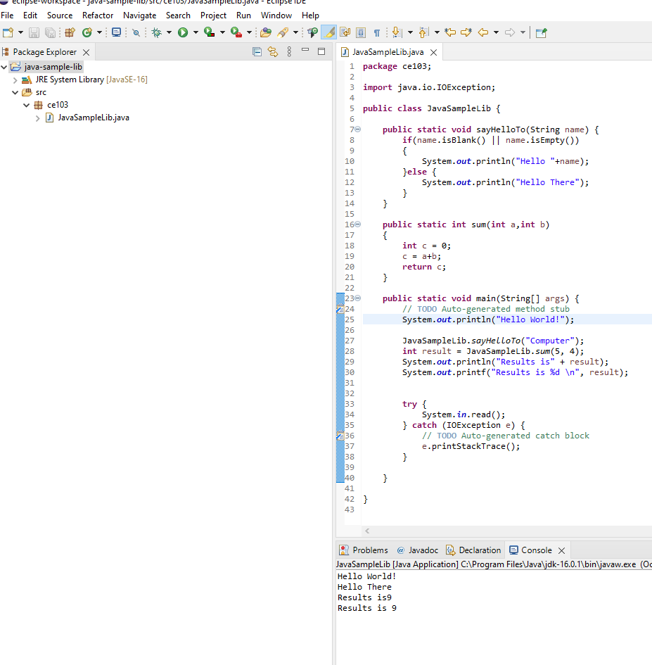

height:500px

There is no exe files java runtime environment run class files but we can export this as an executable.

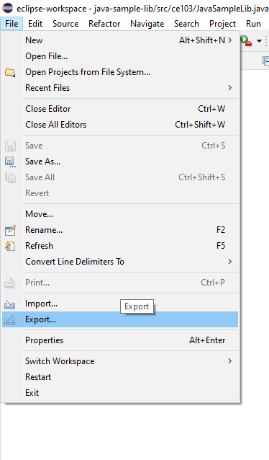

height:500px

Select Java->Runnable JAR File

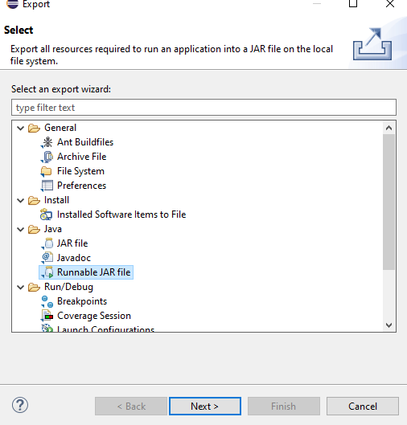

height:500px

click next and set output path for jar file

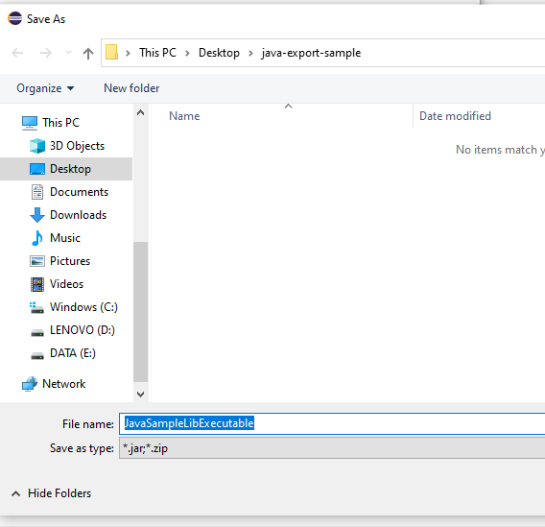

height:500px

If our project has several external dependecy then we can extract this required files (jar, so, dll) in seperated folder or we can combine them and generate a single executable jar

Lets pack everthing together, Select launch configuration that has main function

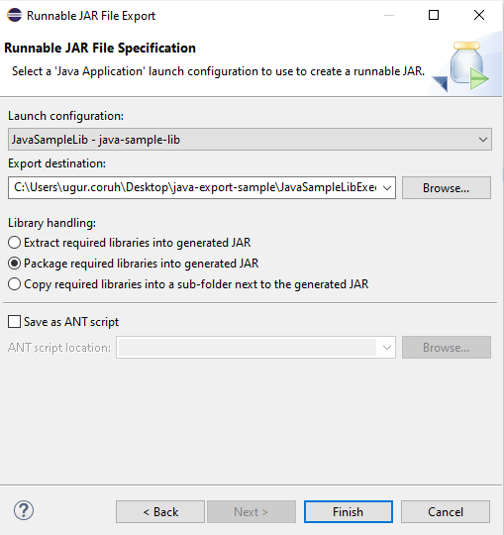

height:500px

end of this operation we will have the following jar that we can by click

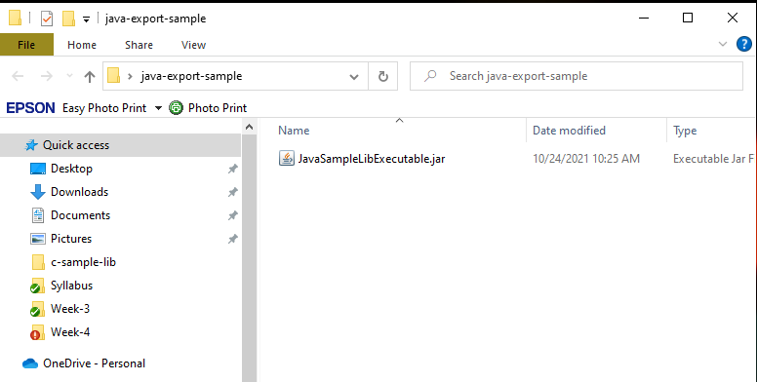

height:500px

When you click application if cannot run then try command line to see problem

enter jar folder and run the following command

java -jar JavaSampleLibExecutable.jar

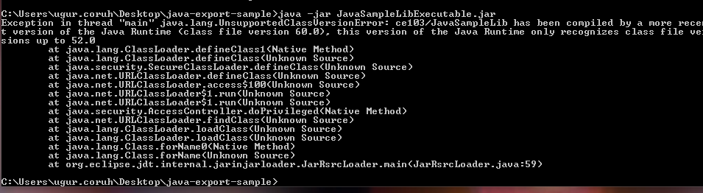

height:200px

In my case eclipse build JDK is newer than that I installed and set for my OS

If we check version we can see problem Java version 1.8.0_231

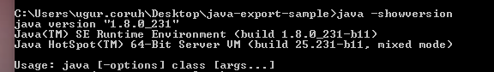

height:100px

We can found installed and builded JDK for our application from Eclipse setting

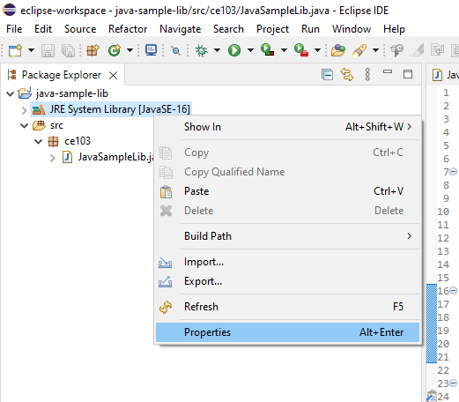

height:500px

select environments

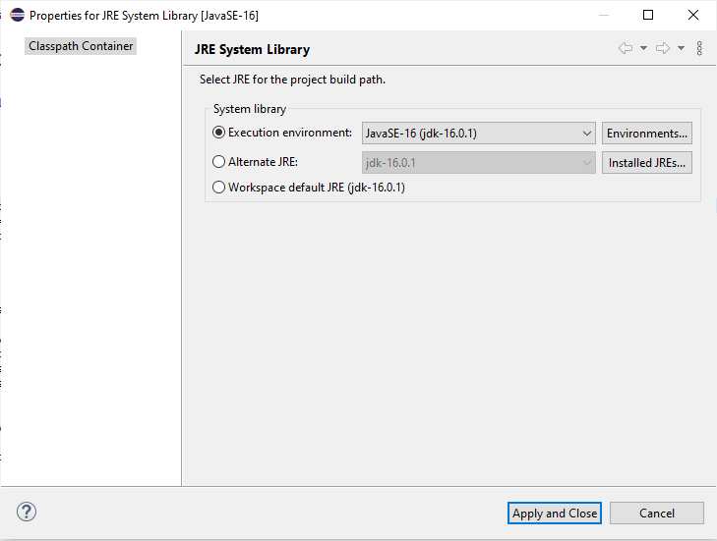

height:500px

select installed JRE or JDK

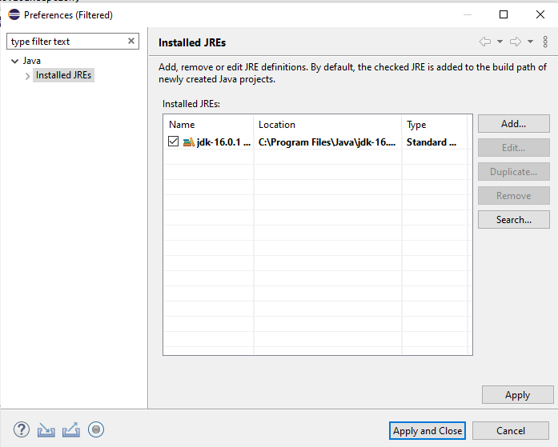

height:500px

you can see installed JRE or JDK home

C:\Program Files\Java\jdk-16.0.1

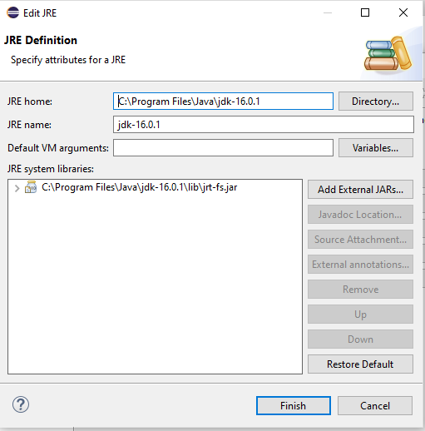

height:400px

Open system environment to fix this problem

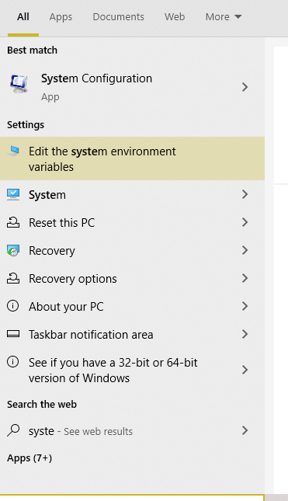

height:500px

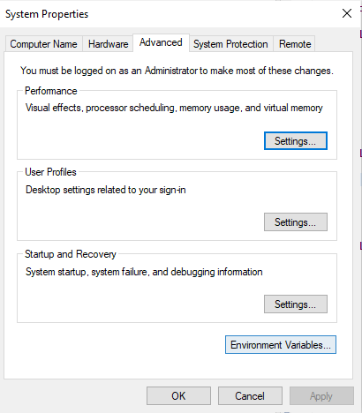

height:500px

Check user settings first

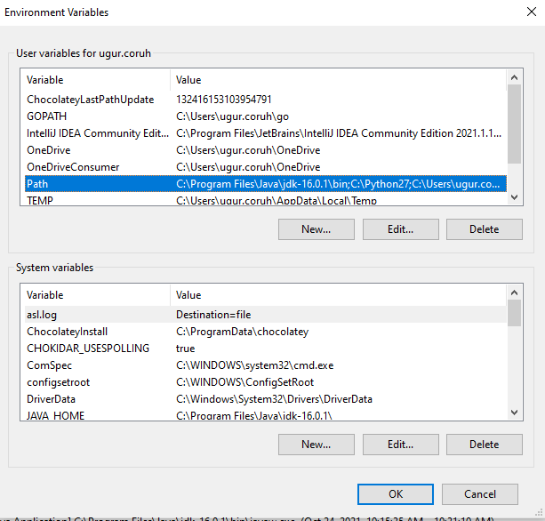

height:500px

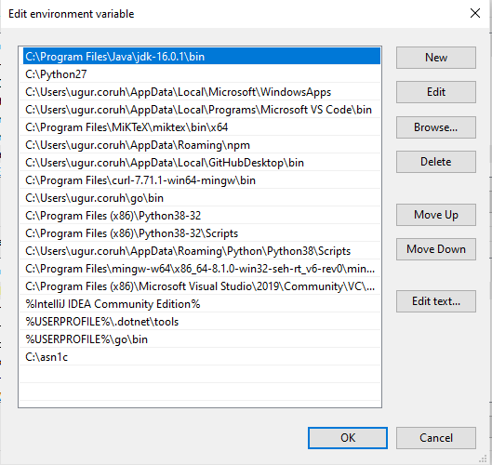

height:500px

Check system settings

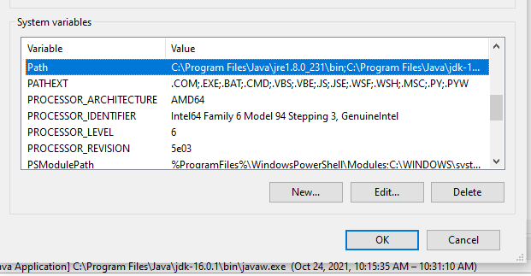

height:500px

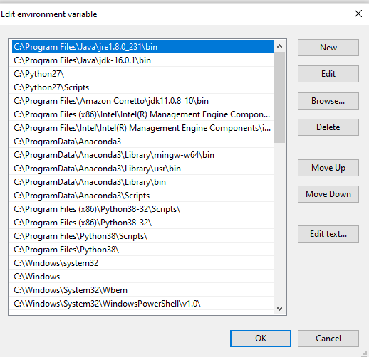

height:500px

we will move up the JDK 16 configuration then command line will run first java

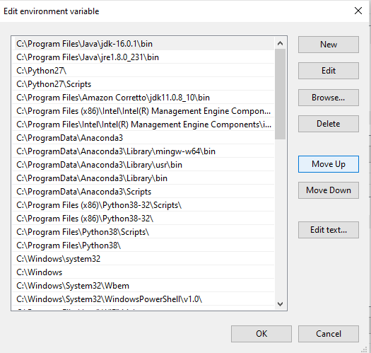

height:500px

Also in system setting check JAVA_HOME

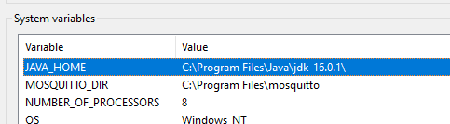

height:500px

After this settings close current command line and open new one

write

java --version

if you see java version updated and 16.0.1 then settings are correct

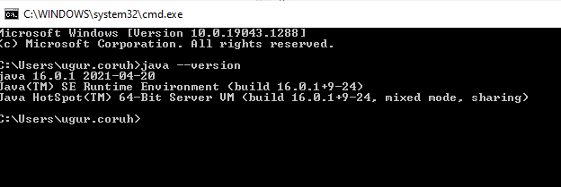

height:500px

and now if we enter and run application as follow we will see output

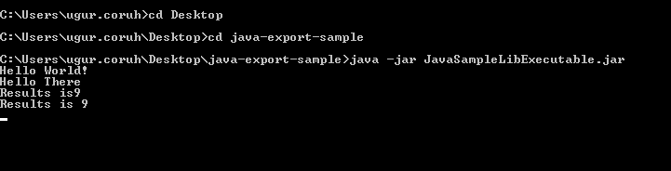

height:500px

But when you click this jar its not running as you see so we have options to provide a clickable application there

Launch4j is an option here

[Launch4j - Cross-platform Java executable wrapper](http://launch4j.sourceforge.net/index.html)

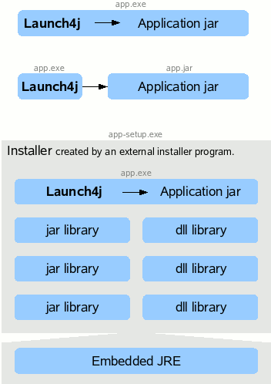

How to use Launch4

you can watch this tutorial also

[How to convert jar to exe using Launch4J Full explanation - YouTube](https://www.youtube.com/watch?v=MyMPPuYGN-U&ab_channel=GoXR3PlusStudio)

Download and install launch4j and open application

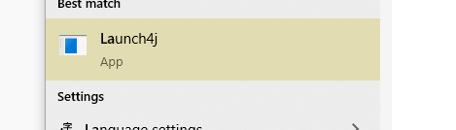

height:200px

configure your application settings similar to below select jar file and exe output path

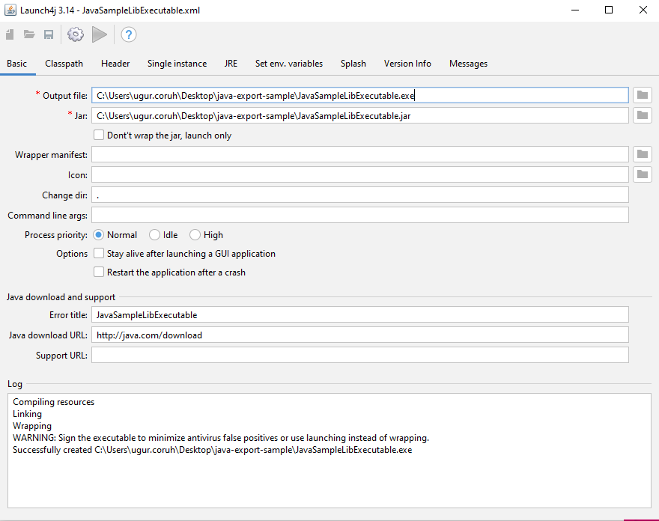

height:500px

we can customize main class if have multiple main class

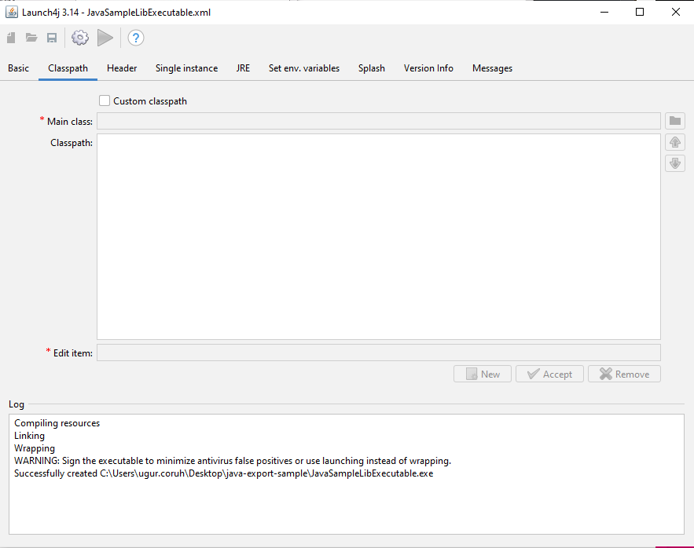

height:500px

select console from setting for this application

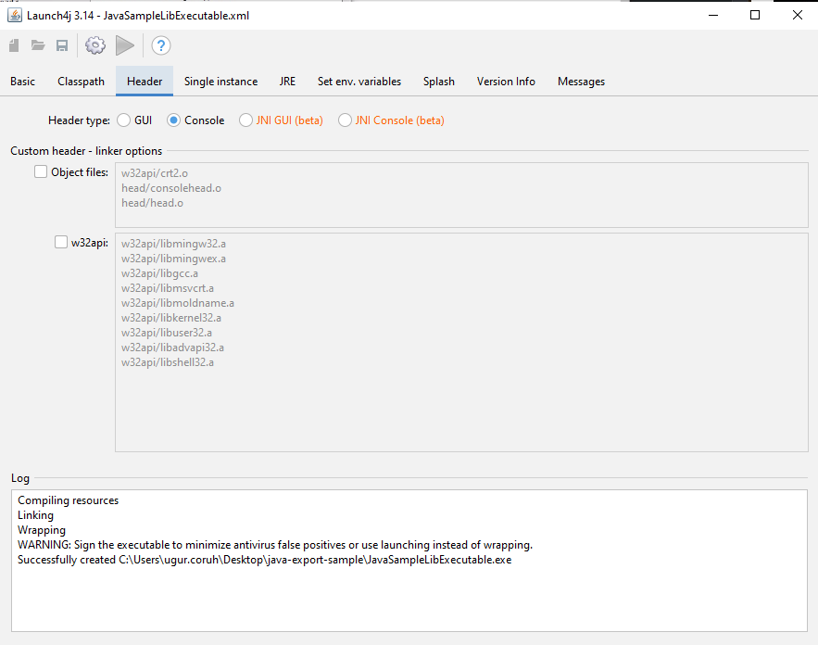

height:500px

we can provide a single running application, this setting avoid to run multiple instances

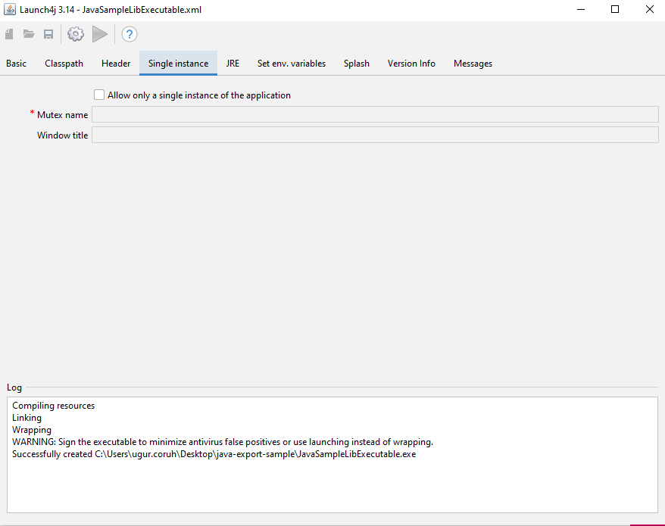

height:500px

we need to set runtime environment versions

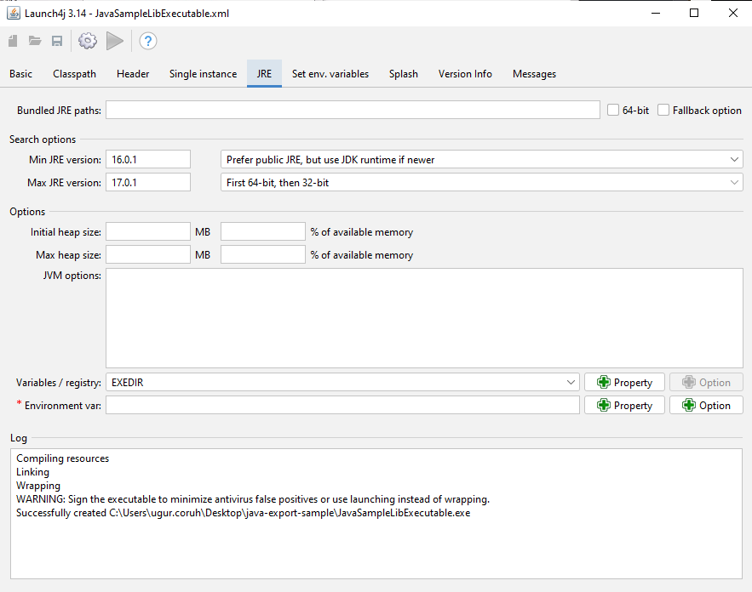

height:500px

you can set system parameters before running application

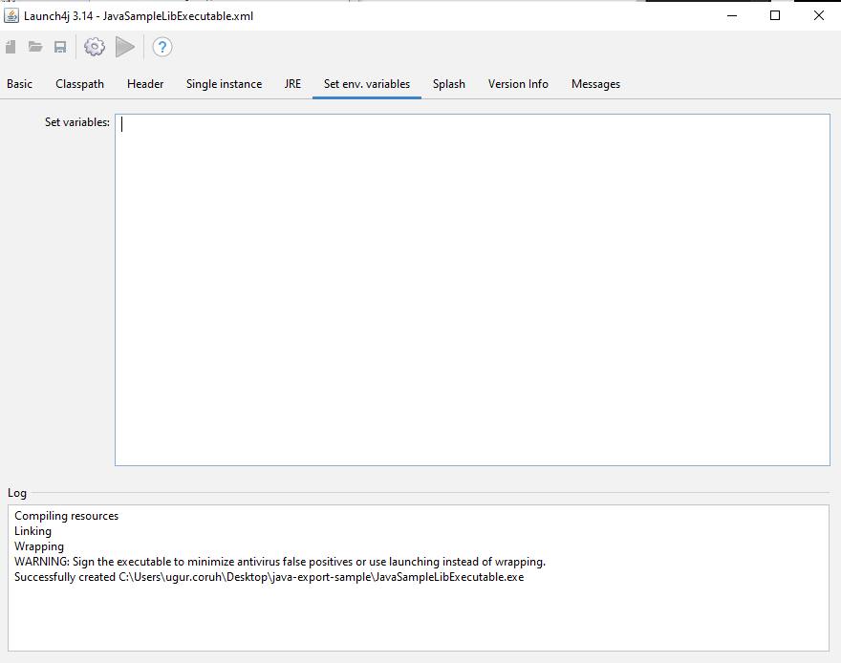

height:500px

with splash screen you can show a splash screen image for your application

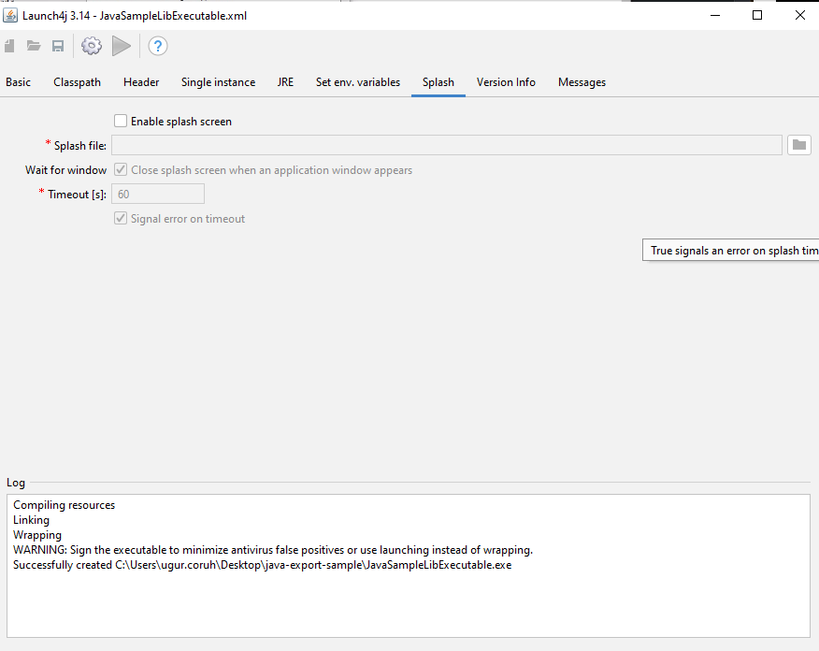

height:500px

File attributes such as version product information is configured from version info tab

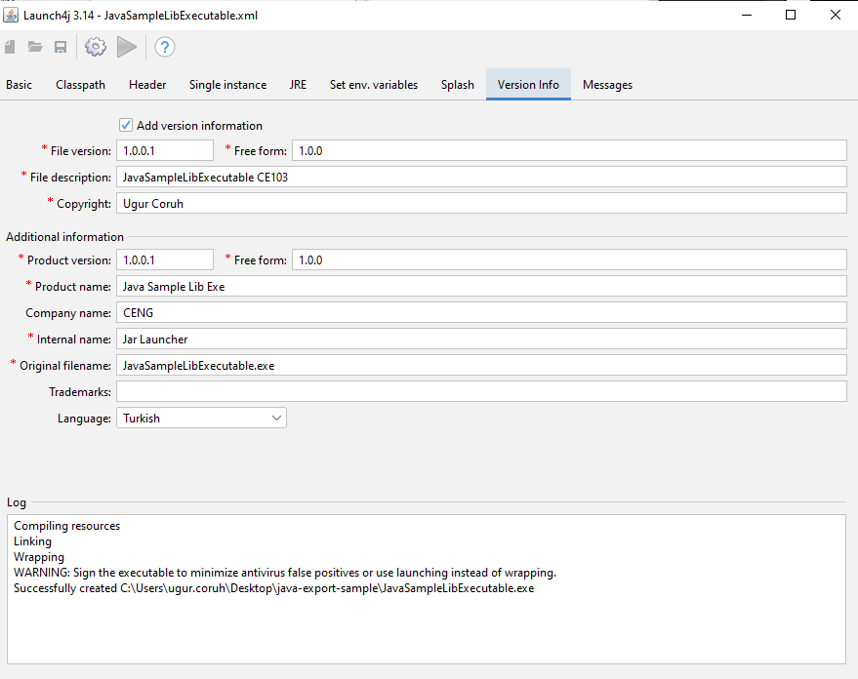

height:500px

if your application runtime condition has an error then you can show this customized messages also

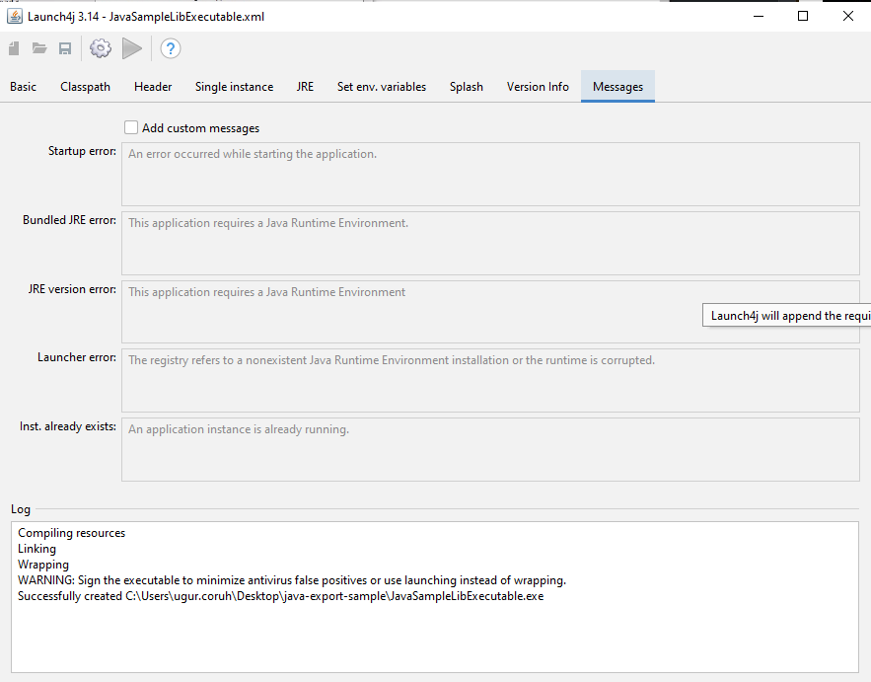

height:500px

with this options save configuration file xml

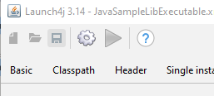

height:500px

and compile settings

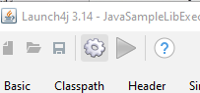

height:500px

you will see generated output file in log screen

Compiling resources  
Linking  
Wrapping  
WARNING: Sign the executable to minimize antivirus false positives or use launching instead of wrapping.  
Successfully created C:\Users\ugur.coruh\Desktop\java-export-sample\JavaSampleLibExecutable.exe

now we can run exe by click

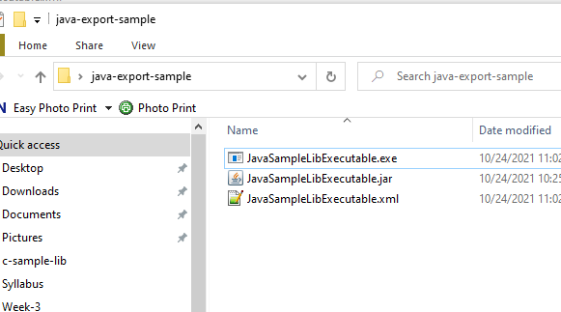

height:300px

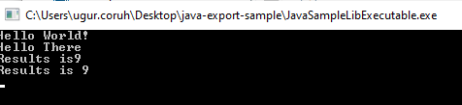

height:200px

another option here adding a bat file to run current jar file

**JavaSampleLibExecutable.bat**

java -jar JavaSampleLibExecutable.jar

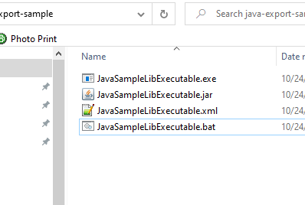

height:200px

if we click bat file then we will automate command line task for current jar file

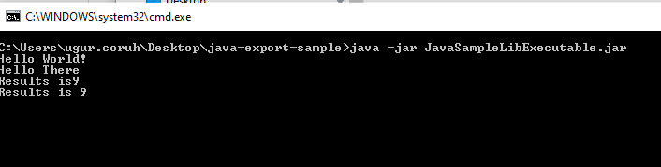

height:200px

Now return back to our java library and create another console application that use library functions

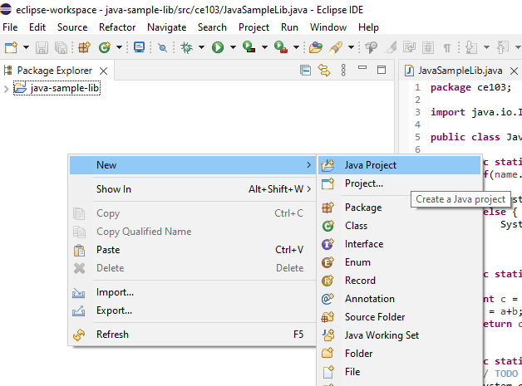

height:500px

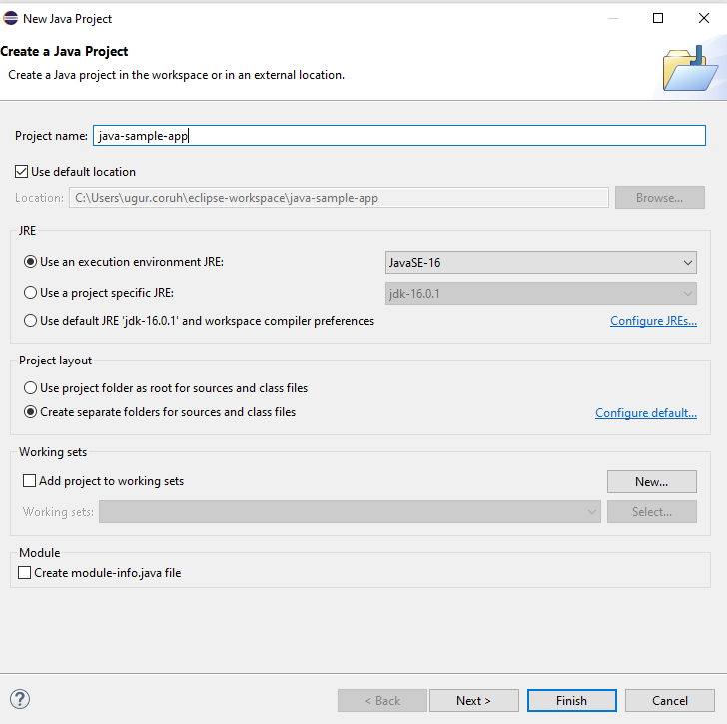

height:500px

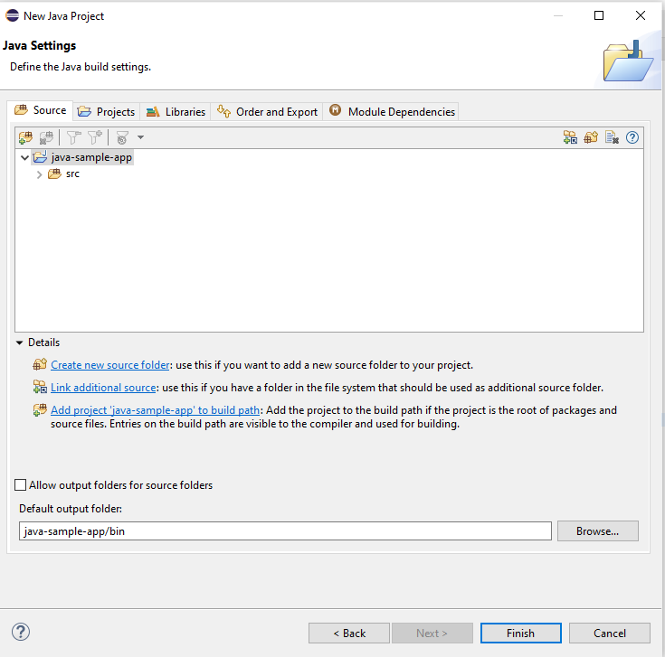

height:500px

you can set libraries in this step from but our library should exported for our solution

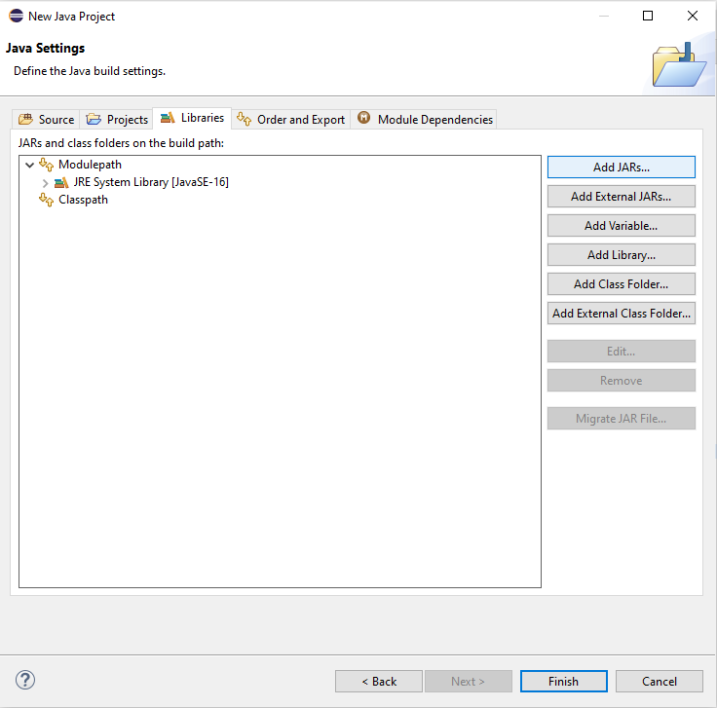

height:500px

Select Add External JARs…



height:200px

Open Exported jar folder and select

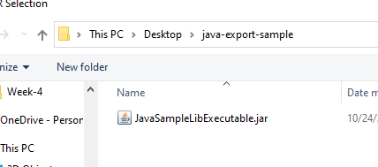

height:500px

Or we can select by Add jar from current workspace

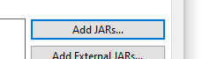

height:200px

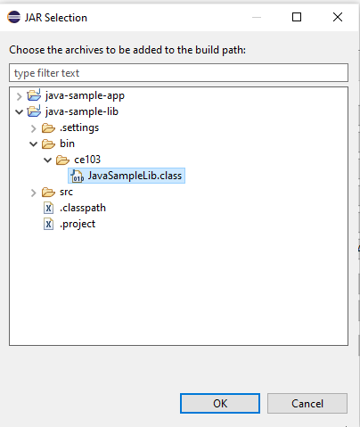

height:200px

but in this step I won’t add anything I’ll add references later

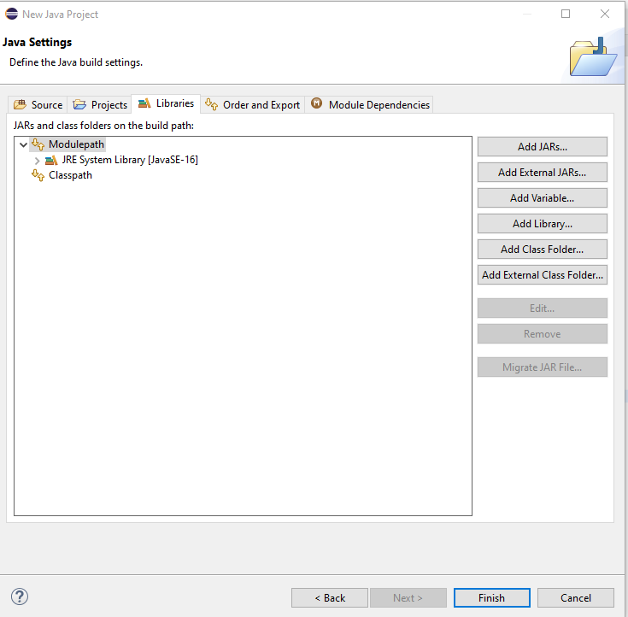

height:500px

we will have the following project

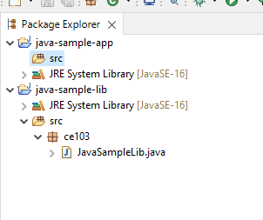

height:500px

lets create a package

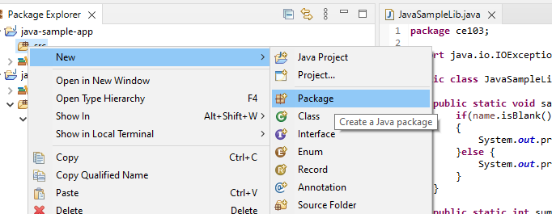

height:500px

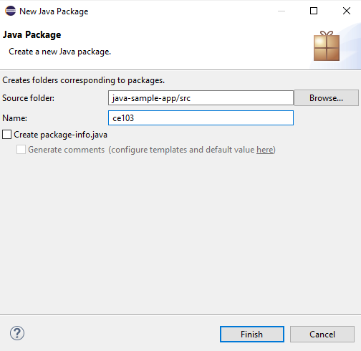

height:500px

and lets create a main class for our application

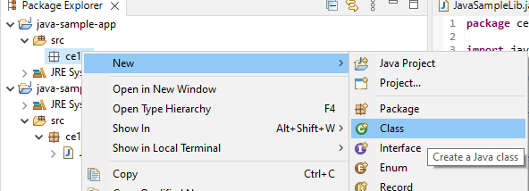

height:500px

check create main function

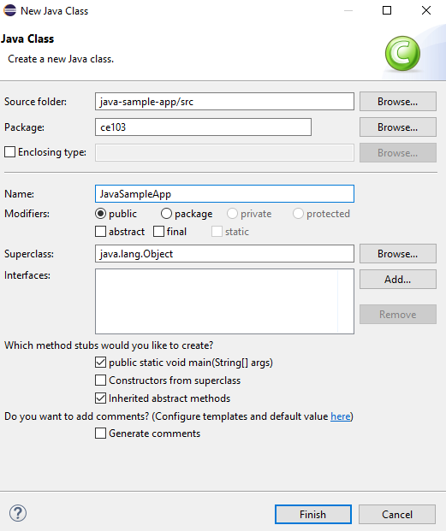

height:500px

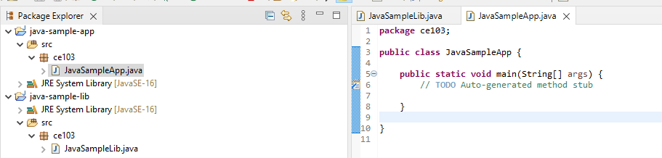

height:500px

right click to project and add reference

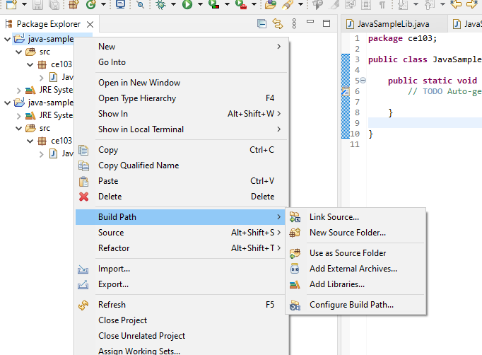

height:500px

you can enter same configurations from project properties

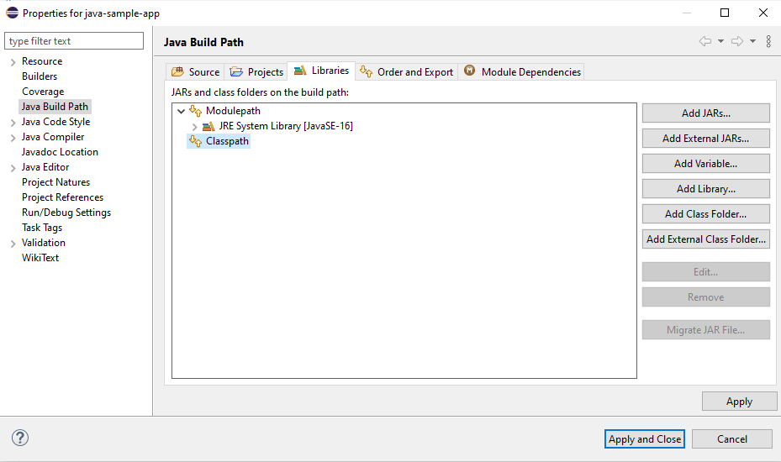

height:500px

Lets export our library as a JAR file and then add to our classpath

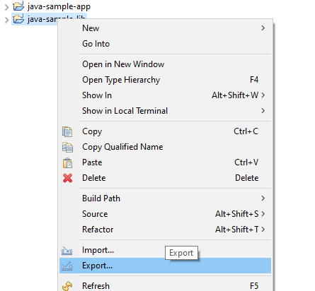

height:500px

Select JAR file

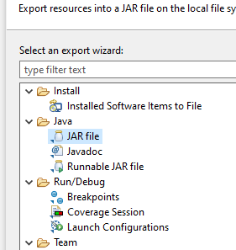

height:500px

we configured output as

C:\Users\ugur.coruh\Desktop\java-export-sample\JavaSampleLib.jar

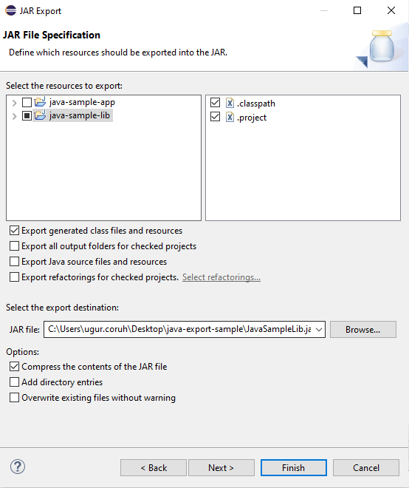

height:500px

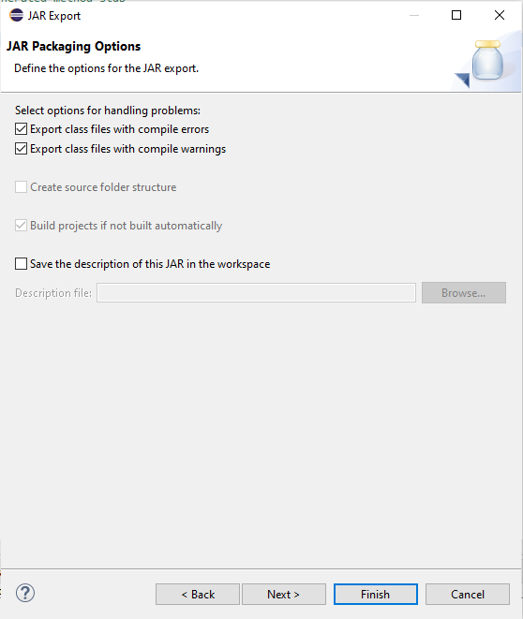

height:500px

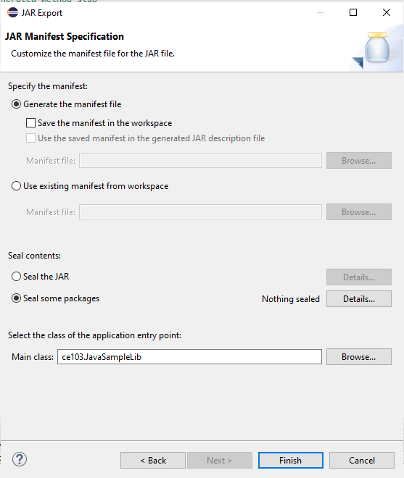

height:500px

In the same export folder now we have JavaSampleLib.jar

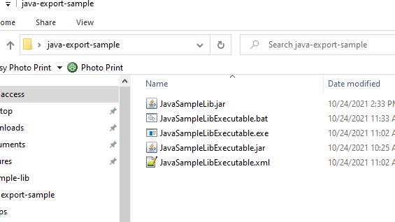

height:500px

return back to java-sample-app and then add this jar file to our project

Build Path->Add External Archives

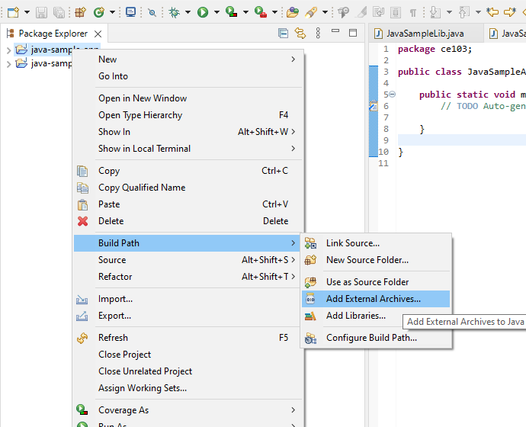

height:500px

you will see its added to reference libraries

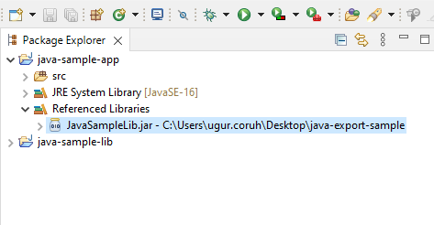

height:500px

in our JavaSampleApp.java we can use the following source codes

package ce103;  
  
import java.io.IOException;  
  
public class JavaSampleApp {  
  
 public static void main(String[] args) {  
 // TODO Auto-generated method stub  
  
 System.out.println("Hello World!");  
  
 JavaSampleLib.sayHelloTo("Computer");  
 int result = JavaSampleLib.sum(5, 4);  
 System.out.println("Results is" + result);  
 System.out.printf("Results is %d \n", result);  
  
  
 try {  
 System.in.read();  
 } catch (IOException e) {  
 // TODO Auto-generated catch block  
 e.printStackTrace();  
 }  
  
 }  
  
}

When we run application we will see similar output

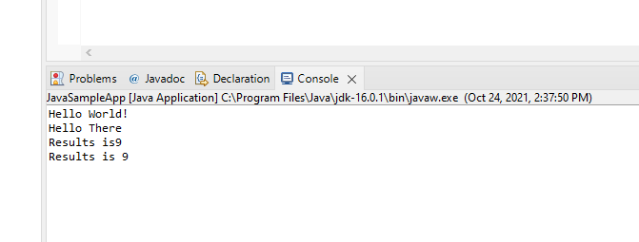

height:500px

Lets export this application with its dependent library

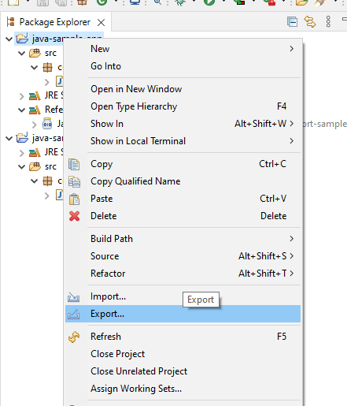

height:500px

Select runnable jar

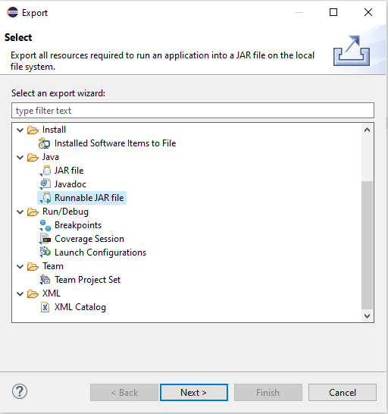

height:500px

Set Launch configuration and Export destination

C:\Users\ugur.coruh\Desktop\java-export-sample\JavaSampleAppSingle.jar

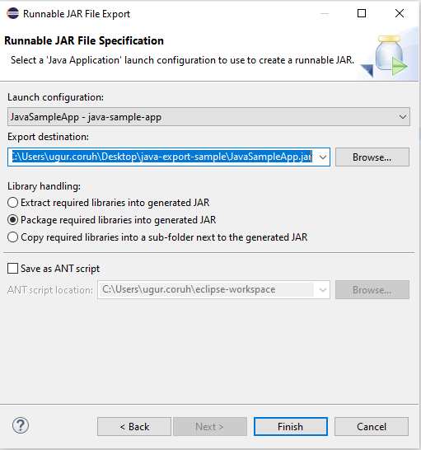

height:500px

In this option we will have single jar file

In the export folder we do not see reference libraries

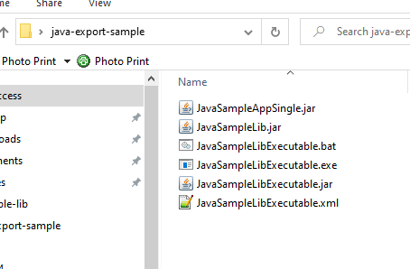

height:200px

and we can run with command line

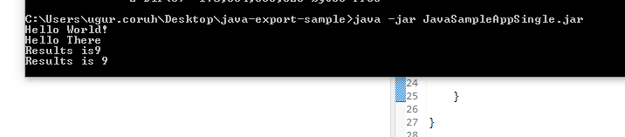

height:200px

only change copy required libraries setting and then give a new name for new jar file and export

C:\Users\ugur.coruh\Desktop\java-export-sample\JavaSampleAppMultiple.jar

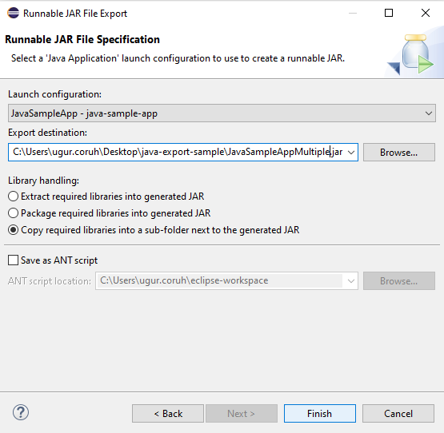

height:500px

now we have a folder that contains our libraries referenced

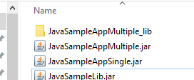

height:500px

in this file we can find our library

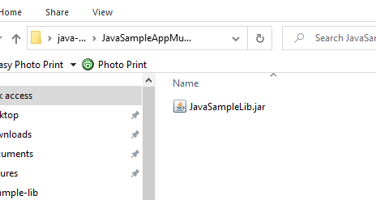

height:500px

if we test our application we will see it will work

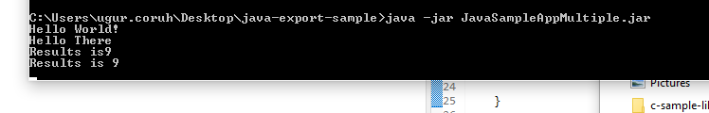

height:200px

if we delete JavaSampleLib.jar and then try running application we will get error

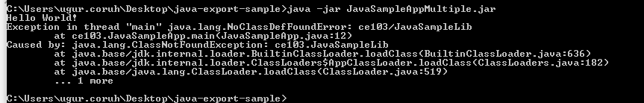

height:200px

## Program Testing

## Unit Test Development

### C Unit Tests

#### Visual Studio Community Edition

### C++ Unit Tests

#### Visual Studio Community Edition

[C/C++ için birim testleri yazma - Visual Studio (Windows) | Microsoft Docs](https://docs.microsoft.com/tr-tr/visualstudio/test/writing-unit-tests-for-c-cpp?view=vs-2019)

Use cpp-sample-lib project and add

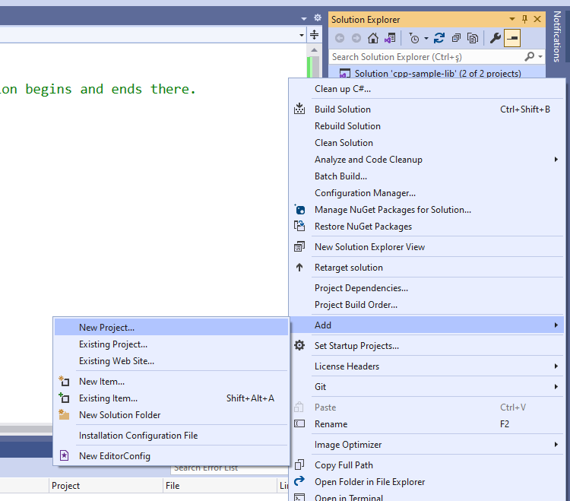

height:500px

select Native Unit Test

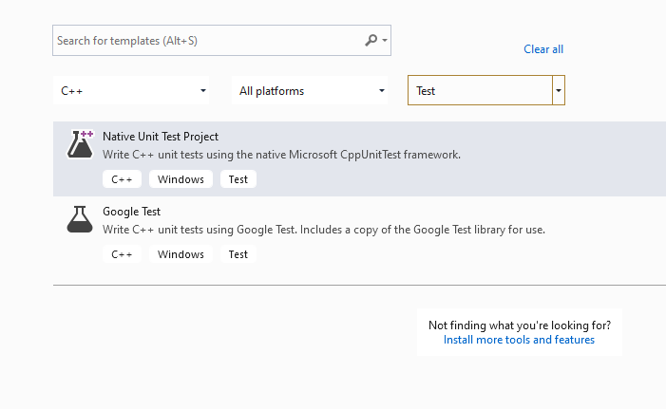

height:500px

set project path and name

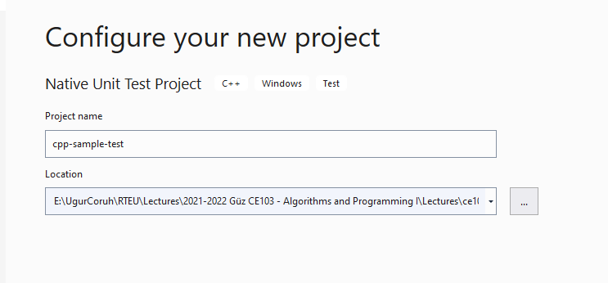

height:500px

you will have cpp-sample-test project

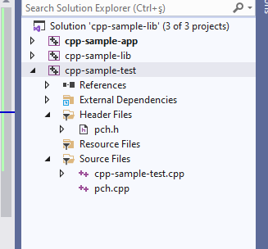

height:500px

add library project from references

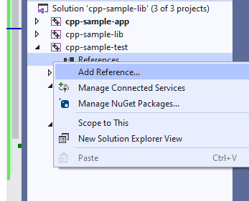

height:500px

Add cpp-sample-lib to cpp-sample-test project

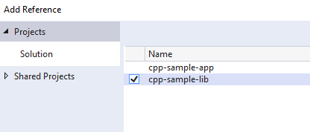

height:500px

cpp-sample-test.cpp

#include "pch.h"  
#include "CppUnitTest.h"  
#include "..\cpp-sample-lib\samplelib.h"  
  
using namespace Microsoft::VisualStudio::CppUnitTestFramework;  
  
namespace cppsampletest  
{  
 TEST_CLASS(cppsampletest)  
 {  
 public:  
  
 TEST_METHOD(TestSumCorrect)  
 {  
 Assert::AreEqual(9, sum(4, 5));  
 }  
  
 TEST_METHOD(TestSumInCorrect)  
 {  
 Assert::AreEqual(10, sum(4, 5));  
 }  
 };  
}

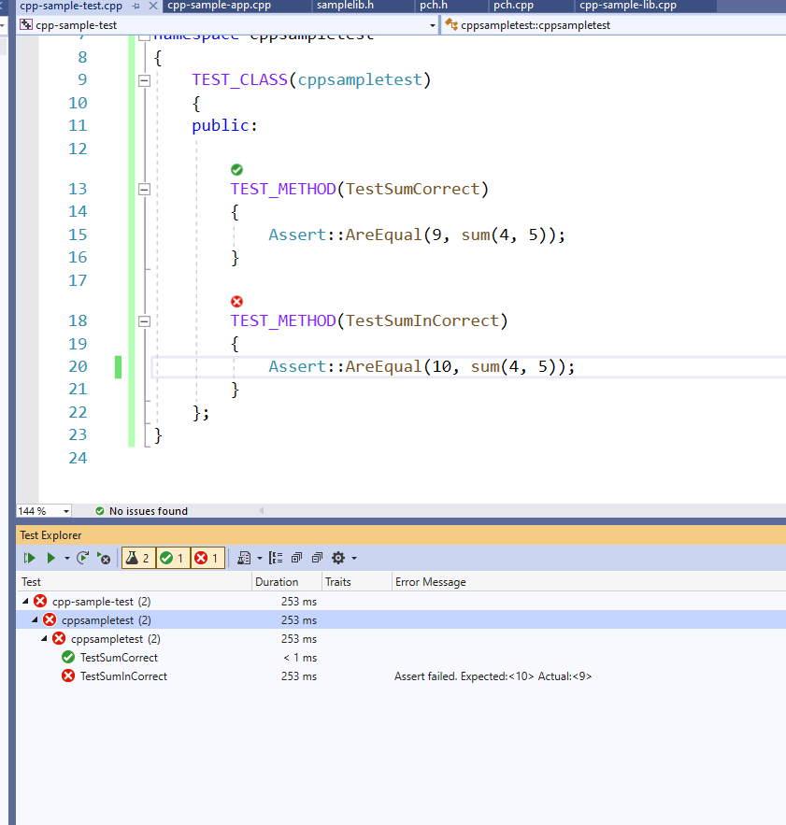

height:500px

### C# Unit Tests

### Visual Studio Community Edition (MSTestV2+.Net)

Install extension fine code coverage

https://marketplace.visualstudio.com/items?itemName=FortuneNgwenya.FineCodeCoverage

Create a .Net Framework Library

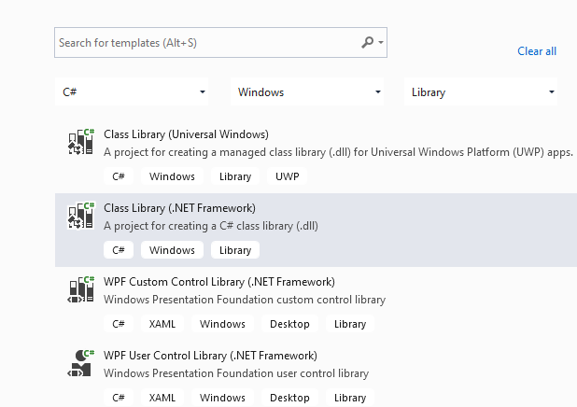

height:500px

set project framework and path

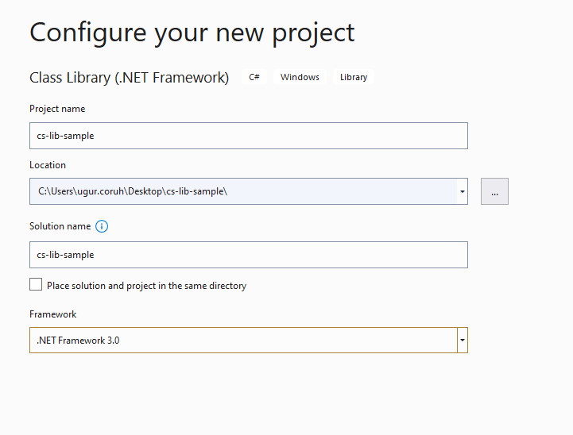

height:500px

Create library functions

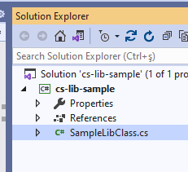

height:500px

using System;  
using System.Collections.Generic;  
using System.Text;  
  
namespace cs_lib_sample  
{  
 public class SampleLibClass  
 {  
 public static string sayHelloTo(string name)  
 {  
 string result = String.Empty;  
  
 if (!String.IsNullOrEmpty(name))  
 {  
 result = "Hello " + name;  
 }  
 else  
 {  
 result = "Hello There";  
 }  
  
 Console.WriteLine(result);  
  
 return result;  
 }  
  
 public static int sum(int a, int b)  
 {  
 int c = 0;  
 c = a + b;  
 return c;  
 }  
  
 public int multiply(int a, int b)  
 {  
 return a * b;  
 }  
 }  
}

right click and then create unit test project

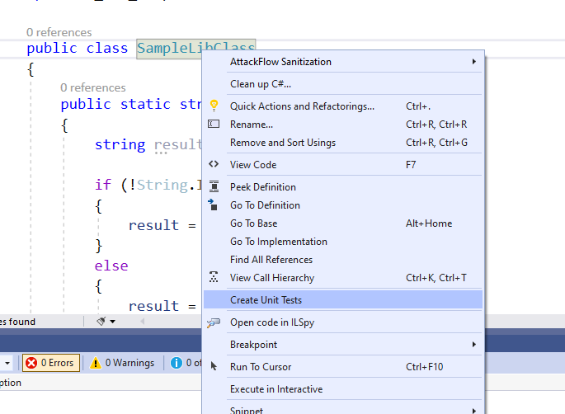

height:500px

press OK

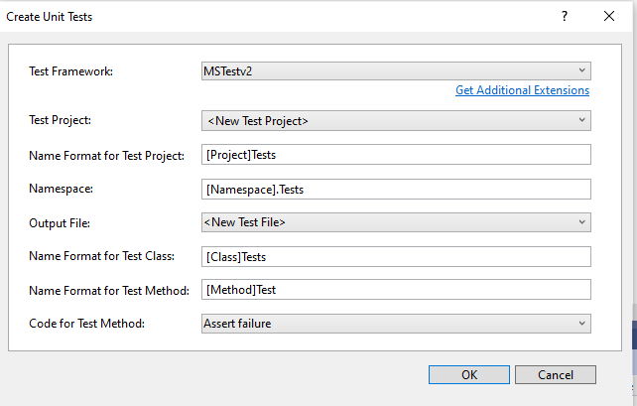

height:500px

enter test code

using Microsoft.VisualStudio.TestTools.UnitTesting;  
using cs_lib_sample;  
using System;  
using System.Collections.Generic;  
using System.Linq;  
using System.Text;  
using System.Threading.Tasks;  
  
namespace cs_lib_sample.Tests  
{  
 [TestClass()]  
 public class SampleLibClassTests  
 {  
  
 [TestMethod()]  
 public void testSayHelloTo()  
 {  
  
  
 Assert.AreEqual("Hello Computer", SampleLibClass.sayHelloTo("Computer"), "Regular say hello should work");  
 }  
 [TestMethod()]  
 public void testSayHelloToWrong()  
 {  
 Assert.AreEqual("Hello All", SampleLibClass.sayHelloTo("Computer"), "Regular say hello won't work");  
 }  
  
  
 [TestMethod()]  
 public void testSumCorrect()  
 {  
 Assert.AreEqual(9, SampleLibClass.sum(4, 5), "Regular sum should work");  
 }  
  
 [TestMethod()]  
 public void testSumWrong()  
 {  
 Assert.AreEqual(10, SampleLibClass.sum(4, 5), "Regular sum shouldn't work");  
 }  
  
 [TestMethod()]  
 public void testMultiply()  
 {  
 SampleLibClass sampleLib = new SampleLibClass();  
  
 Assert.AreEqual(20, sampleLib.multiply(4, 5), "Regular multiplication should work");  
 }  
  
  
 }  
}

Run tests

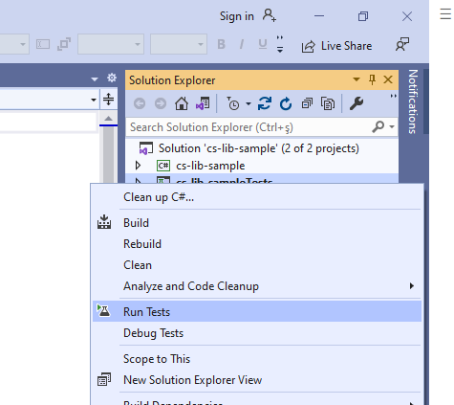

height:500px

you will code coverage and entered or passed branches

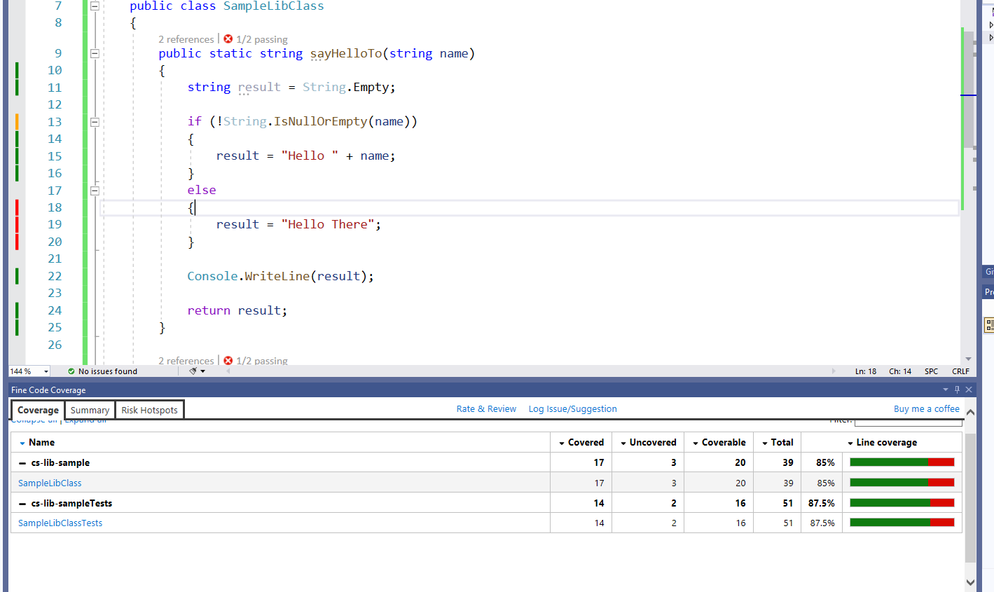

height:500px

#### Visual Studio Community Edition (NUnit+.NETCore)

use cshar-sample-lib for this example

create and add a unit test project to solution

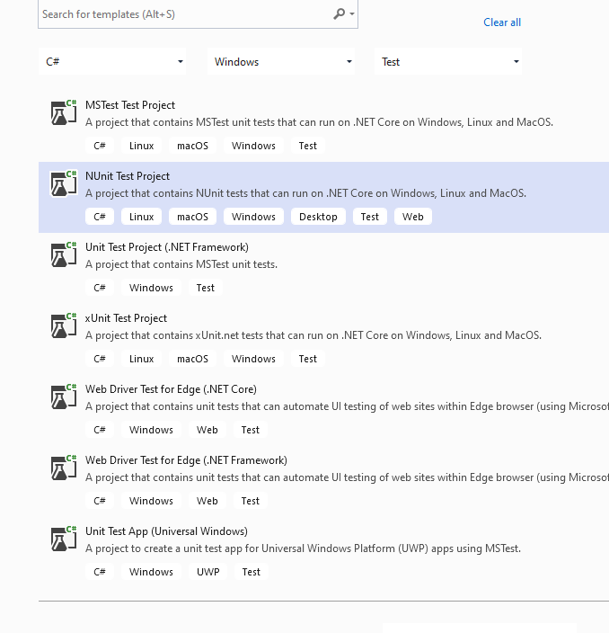

height:500px

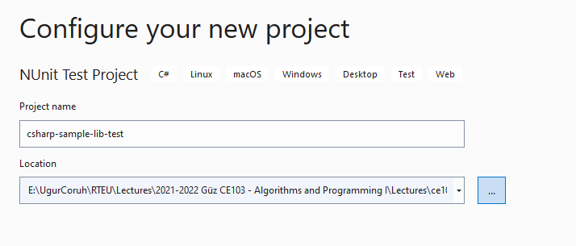

height:500px

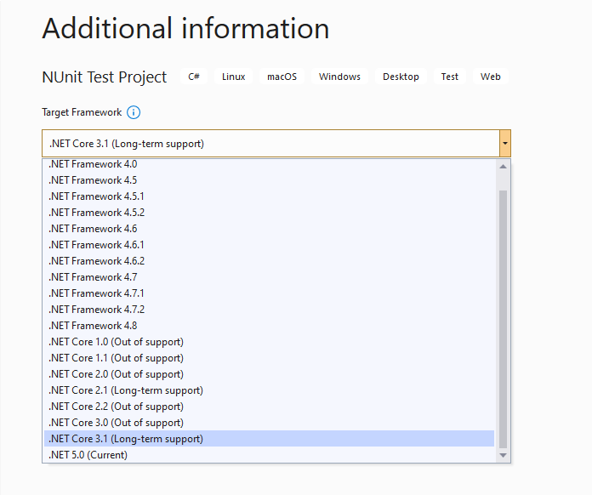

height:500px

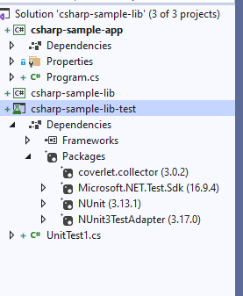

height:500px

Add project reference

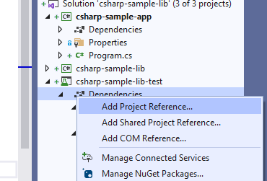

height:500px

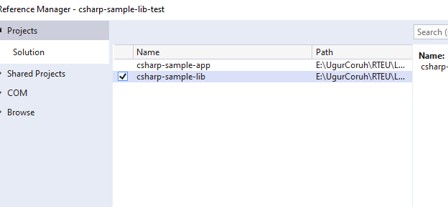

height:500px

SampleLibraryTestClasss in NUnit Project

using csharp_sample_lib;  
using NUnit.Framework;  
  
namespace csharp_sample_lib_test  
{  
 public class SampleLibraryTestClass  
 {  
 sampleLibClass sampleLib;  
  
 [SetUp]  
 public void Setup()  
 {  
 sampleLib = new sampleLibClass();  
 }  
  
 [Test]  
 public void testSayHelloTo()  
 {  
 Assert.AreEqual("Hello Computer", sampleLibClass.sayHelloTo("Computer"), "Regular say hello should work");  
 }  
  
 [Test]  
 public void testSayHelloToWrong()  
 {  
 Assert.AreEqual("Hello All", sampleLibClass.sayHelloTo("Computer"), "Regular say hello won't work");  
 }  
  
  
 [Test]  
 public void testSumCorrect()  
 {  
 Assert.AreEqual(9, sampleLibClass.sum(4, 5), "Regular sum should work");  
 }  
  
 [Test]  
 public void testSumWrong()  
 {  
 Assert.AreEqual(10, sampleLibClass.sum(4, 5), "Regular sum shouldn't work");  
 }  
  
 [Test]  
 public void testMultiply()  
 {  
 Assert.AreEqual(20, sampleLib.multiply(4, 5), "Regular multiplication should work");  
 }  
 }  
}

sample class library

using System;  
  
namespace csharp_sample_lib  
{  
 public class sampleLibClass  
 {  
 public static string sayHelloTo(string name)  
 {  
 string result = String.Empty;  
  
 if (!String.IsNullOrEmpty(name))  
 {  
 result = "Hello " + name;  
 }  
 else  
 {  
 result = "Hello There";  
 }  
  
 Console.WriteLine(result);  
  
 return result;  
 }  
  
 public static int sum(int a, int b)  
 {  
 int c = 0;  
 c = a + b;  
 return c;  
 }  
  
 public int multiply(int a, int b)  
 {  
 return a * b;  
 }  
 }  
}

Open test explorer and run tests

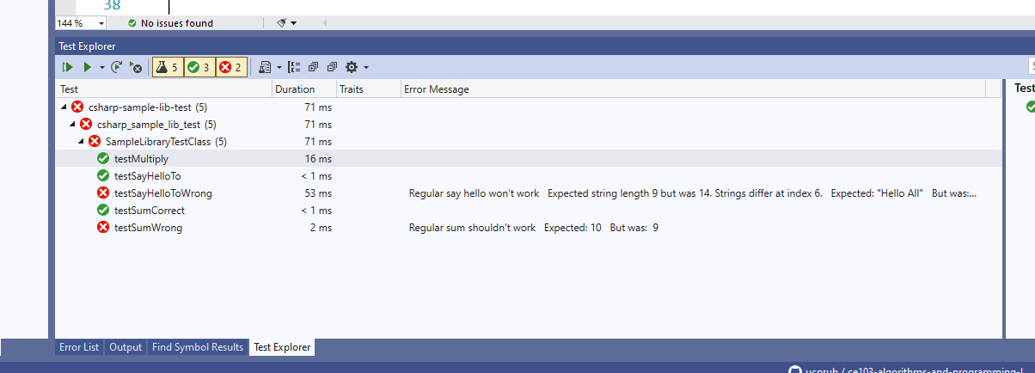

height:500px

or you can run from project

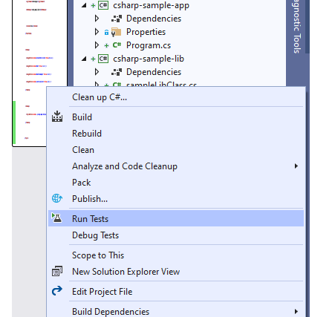

height:500px

Also we can create unit test from library class,

right click the sampleLibClass and select create unit tests but this option do not provide nunit tests.

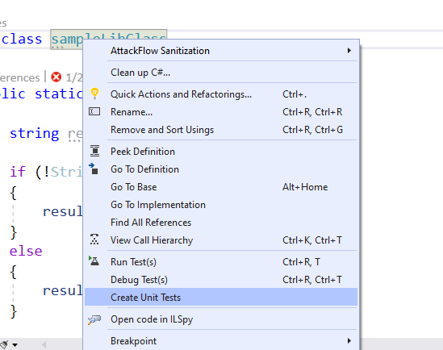

height:500px

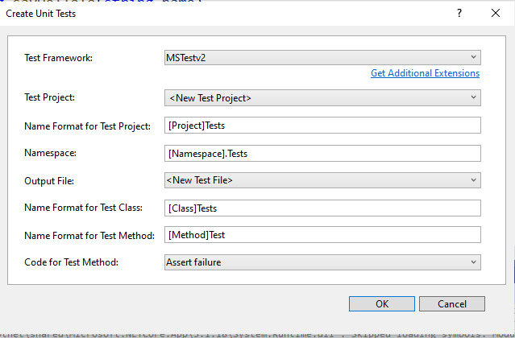

height:500px

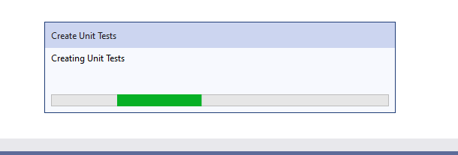

height:500px

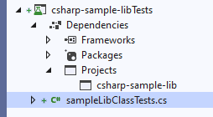

height:500px

using Microsoft.VisualStudio.TestTools.UnitTesting;  
using csharp_sample_lib;  
using System;  
using System.Collections.Generic;  
using System.Text;  
  
namespace csharp_sample_lib.Tests  
{  
 [TestClass()]  
 public class sampleLibClassTests  
 {  
 [TestMethod()]  
 public void sayHelloToTest()  
 {  
 Assert.Fail();  
 }  
  
 [TestMethod()]  
 public void sumTest()  
 {  
 Assert.Fail();  
 }  
  
 [TestMethod()]  
 public void multiplyTest()  
 {  
 Assert.Fail();  
 }  
 }  
}

we will not commit this changes and continue from nunit test project, the fine code

coverage also work for nunit test but not provide inline highlighting

if we run tests we will have the following outputs

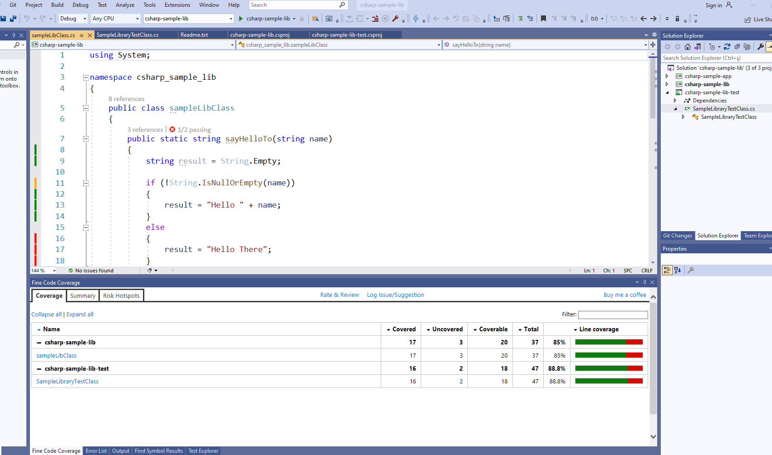

height:500px

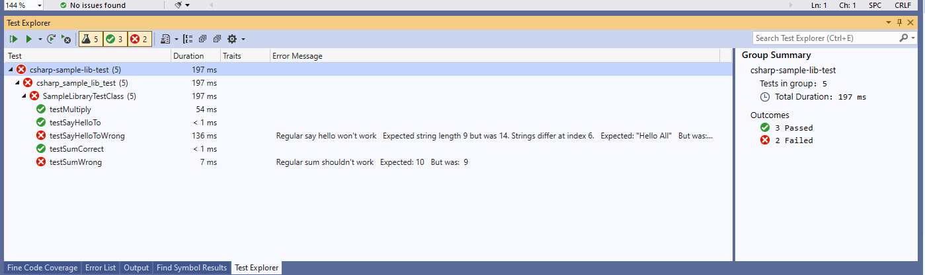

height:500px

Inline code highlight is part of enterprise visual studio edition

[Analyzing code coverage in Visual Studio - DEV Community](https://dev.to/rruizdev/analizando-cobertura-del-codigo-en-visual-studio-1p27)

# TL;DR

Additional information you can use OpenCover + Nunit Runner + Report Generator together to setup a code coverage report but it has complex batch running process. After a few try I decided to use fine code coverage but here is the usage not tested well.

First unit test runner tool doesn’t support .Net Core

[c# - The NUnit 3 driver encountered an error while executing reflected code (NUnit.Engine.NUnitEngineException) - Stack Overflow](https://stackoverflow.com/questions/64611083/the-nunit-3-driver-encountered-an-error-while-executing-reflected-code-nunit-en)

Follow the instructions on the link

[CMD OpenCover · sukhoi1/Useful-Notes Wiki · GitHub](https://github.com/sukhoi1/Useful-Notes/wiki/CMD-OpenCover)

Install OpenCover, ReportGenerator, Nunit,Runners packages then use the package installation folder to get tools that you need

Here is a sample for open cover, select package and copy path

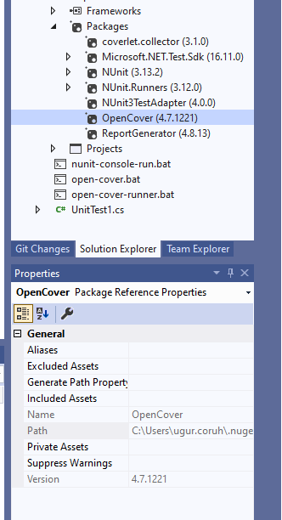

height:500px

Goto path and tools

C:\Users\ugur.coruh\.nuget\packages\opencover\4.7.1221

You need to setup some batch similar with following

run-test-coverage.bat

set pathA=C:\Users\ugur.coruh\.nuget\packages\opencover\4.7.1221\tools  
set pathB=C:\Users\ugur.coruh\.nuget\packages\nunit.consolerunner\3.12.0\tools  
set pathC=C:\Users\ugur.coruh\.nuget\packages\reportgenerator\4.8.13\tools\netcoreapp3.0  
set dllpath=C:\Users\ugur.coruh\Desktop\csharp-sample-lib\csharp-sample-lib-test\bin\Debug\netcoreapp3.1  
  
"%pathA%\OpenCover.Console.exe" ^  
-targetargs:"%dllpath%\csharp-sample-lib-test.dll" ^  
-filter:"+[csharp-sample-lib*]* -[*test]*" ^  
-target:"%pathB%\nunit3-console.exe" ^  
-output:"%dllpath%\coverReport.xml" ^  
-skipautoprops -register:user && "%pathC%\ReportGenerator.exe" -reports:"%dllpath%\coverReport.xml" -targetdir:""%dllpath%\coverage"  
pause

but nunit3-console.exe gives error

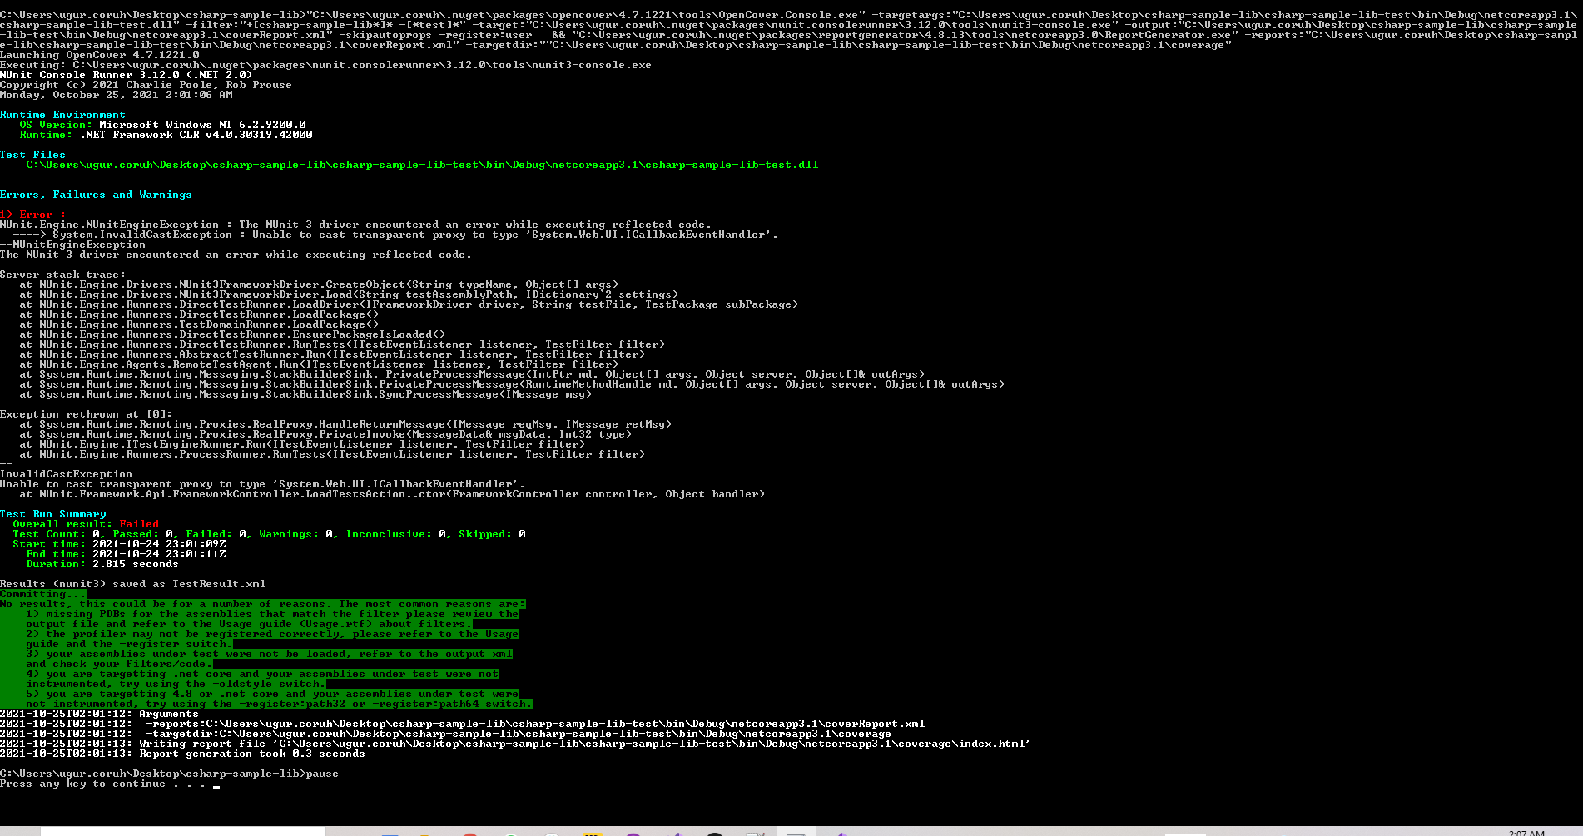

height:300px

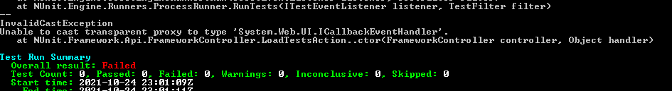

height:200px

for this compatibility issues I prefer to use fine code coverage extension.

OpenCover related studies

[Code coverage of manual or automated tests with OpenCover for .NET applications – Automation Rhapsody](https://automationrhapsody.com/code-coverage-manual-automated-tests-opencover-net-applications/)

[Code coverage of .NET Core unit tests with OpenCover – Automation Rhapsody](https://automationrhapsody.com/code-coverage-net-core-unit-tests-opencover/)

Sample OpenCover report

[Summary - Coverage Report](https://automationrhapsody.com/examples/OpenCover-report/)

### Download and Setup OpenCover, NUnit Console, Report Generator without Package Manager

You can also download the tools from github project pages and install on your operating system,

### OpenCover

[Releases · OpenCover/opencover · GitHub](https://github.com/OpenCover/opencover/releases)

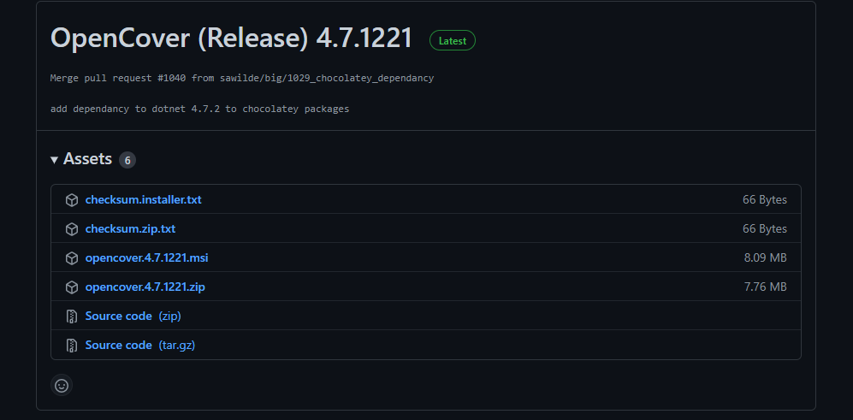

height:500px

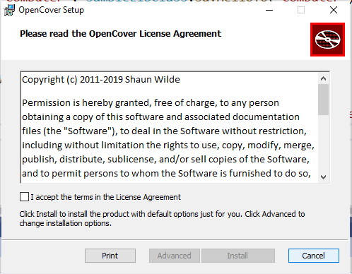

height:500px

Select advanced and then install for all users

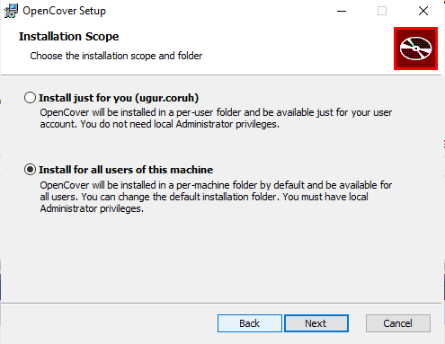

height:500px

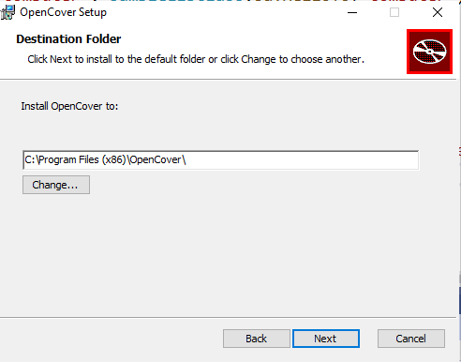

height:500px

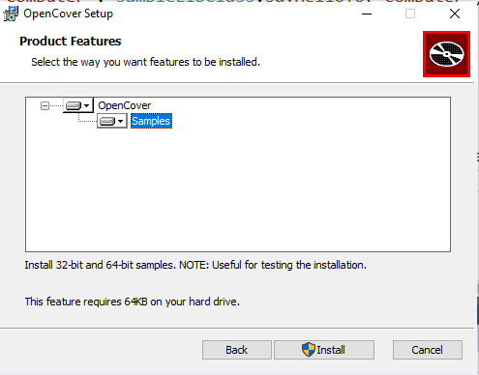

height:500px

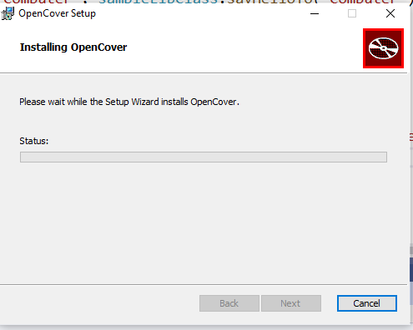

height:500px

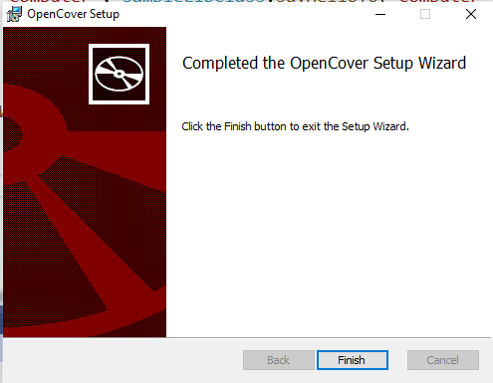

height:500px

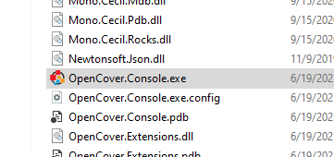

height:500px

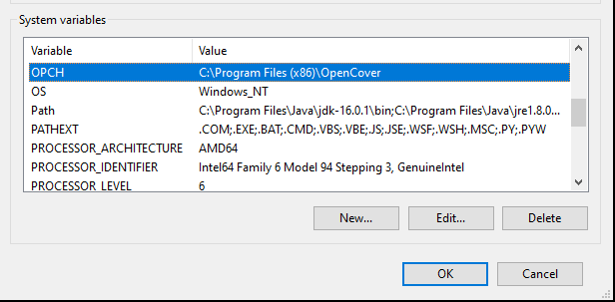

height:400px

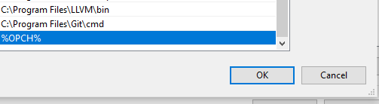

height:200px

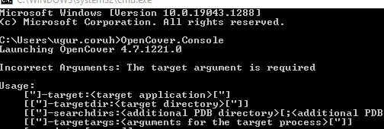

height:500px

### ReportGenerator

[Release ReportGenerator_4.8.13 · danielpalme/ReportGenerator · GitHub](https://github.com/danielpalme/ReportGenerator/releases/tag/v4.8.13)

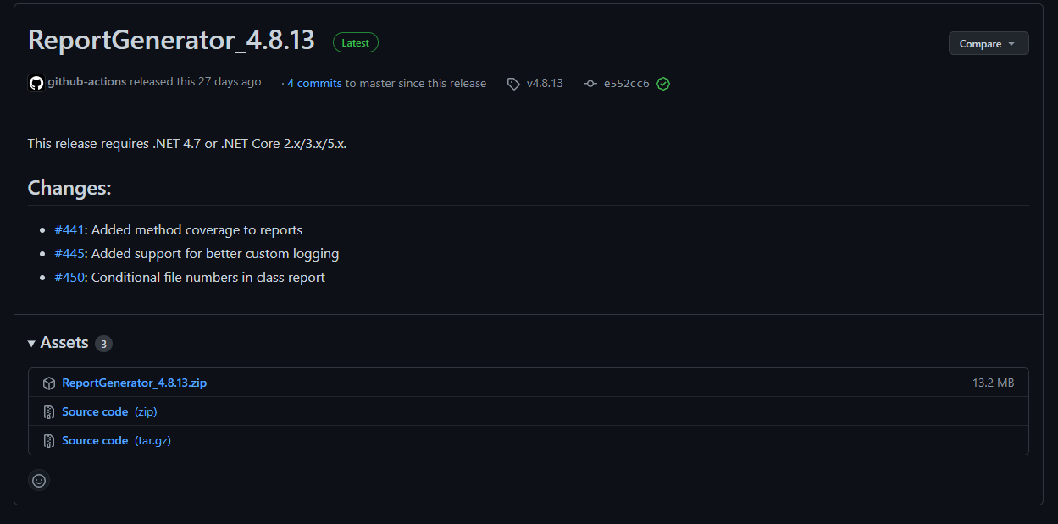

height:500px

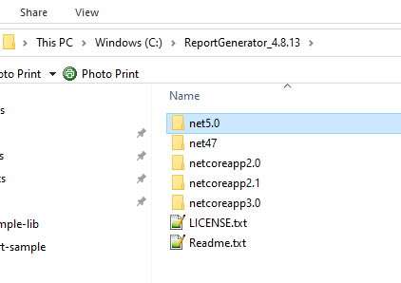

height:500px

### NUnit Console

[Downloads](https://nunit.org/download/)

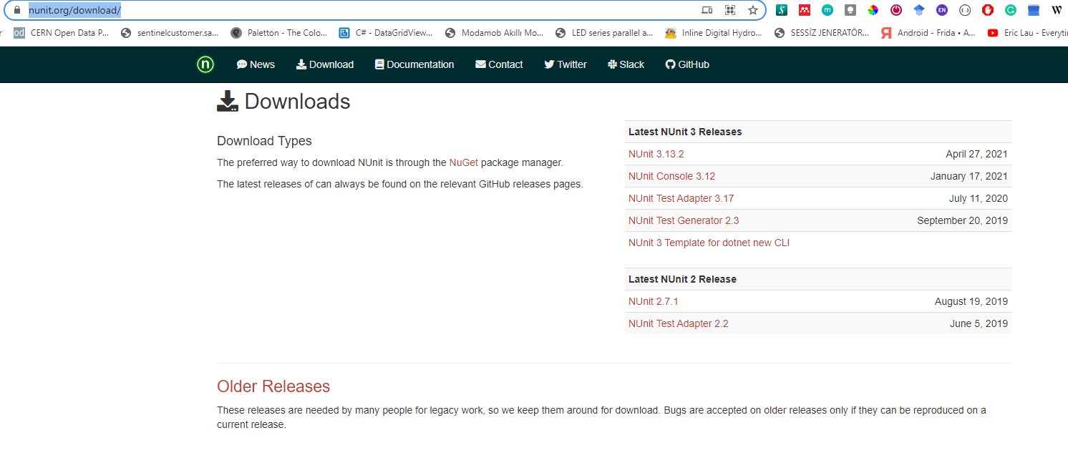

height:500px

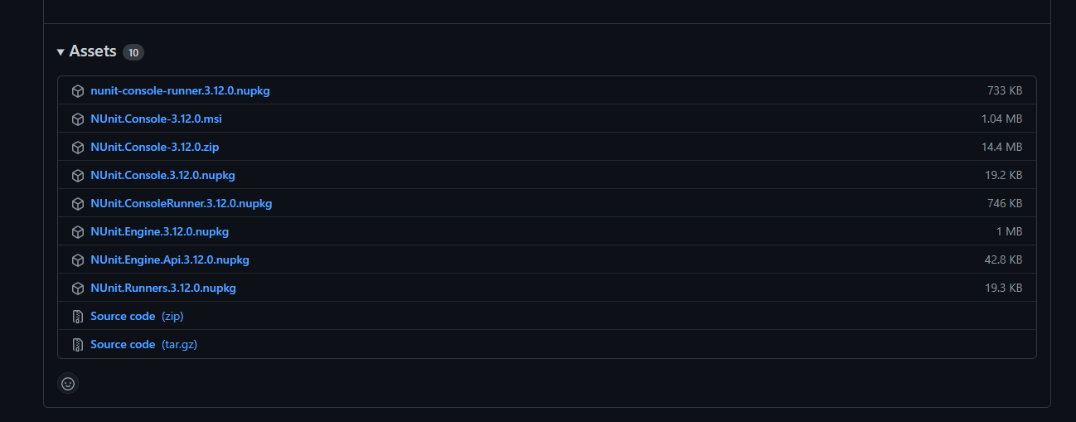

height:500px

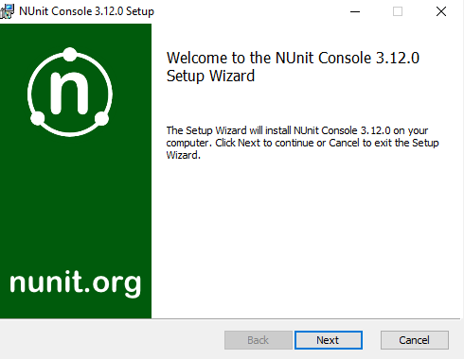

height:500px

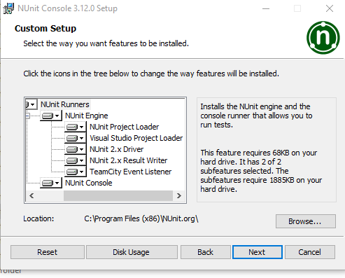

height:500px

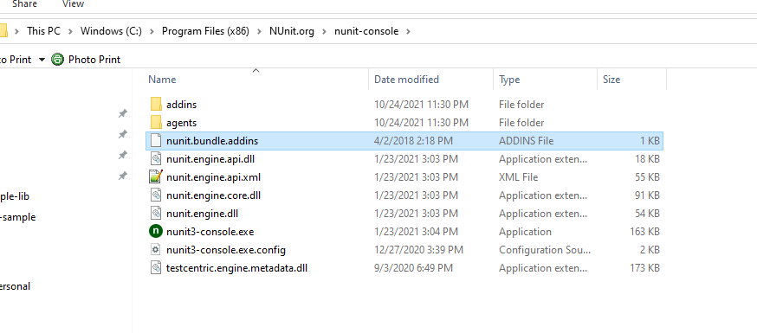

height:500px

### NUnit + MSTest Batch Report Generation (Not Tested)

[OpenCover and ReportGenerator Unit Test Coverage in Visual Studio 2013 and 2015 – CodeHelper.Net](http://codehelper.net/unit-testing/opencover-and-reportgenerator-unit-test-coverage-in-visual-studio-2013-and-2015/)

[OpenCover and ReportGenerator Unit Test Coverage in Visual Studio 2013 and 2015 - CodeProject](https://www.codeproject.com/Articles/1276980/OpenCover-and-ReportGenerator-Unit-Test-Coverage-i)

### Java Unit Tests

#### Eclipse IDE (JUnit4 , JUnit5)

In this sample we will create two example for similar library

Please check the following links

[JUnit 5 tutorial - Learn how to write unit tests](https://www.vogella.com/tutorials/JUnit/article.html)

[JUnit 5](https://junit.org/junit5/)

[JUnit 5 User Guide](https://junit.org/junit5/docs/current/user-guide/)

https://www.eclemma.org/

[JUnit Hello World Example - Examples Java Code Geeks - 2021](https://examples.javacodegeeks.com/core-java/junit/junit-hello-world-example/)

https://yasinmemic.medium.com/java-ile-unit-test-yazmak-birim-test-ca15cf0d024b

#### Java Application + JUnit

In normal java application we can right click the project java-sample-lib and add Junit case

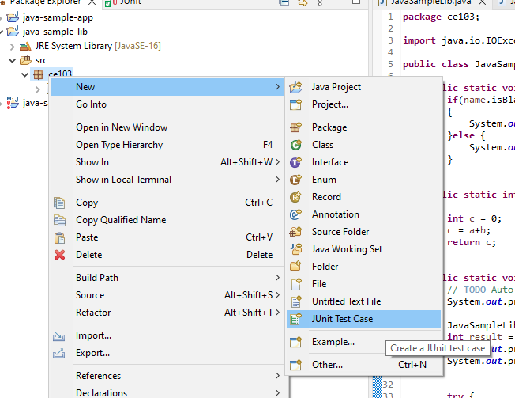

height:500px

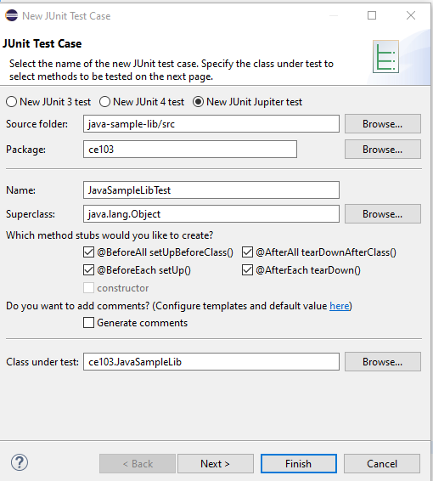

height:500px

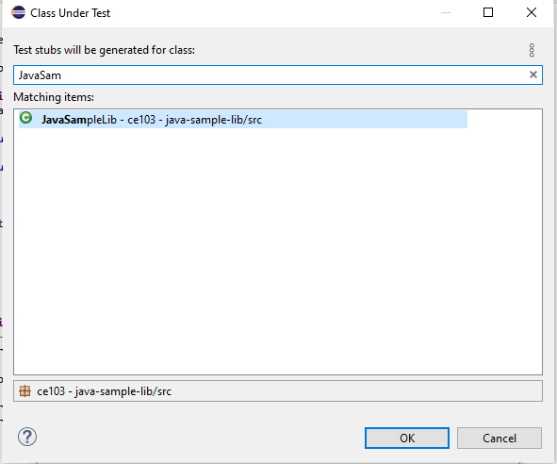

height:500px

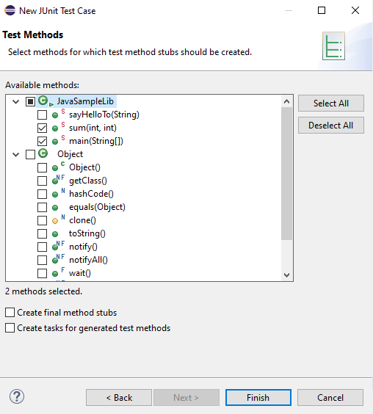

height:500px

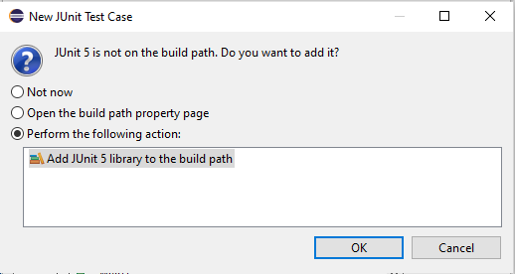

height:500px

and you will have the following test class

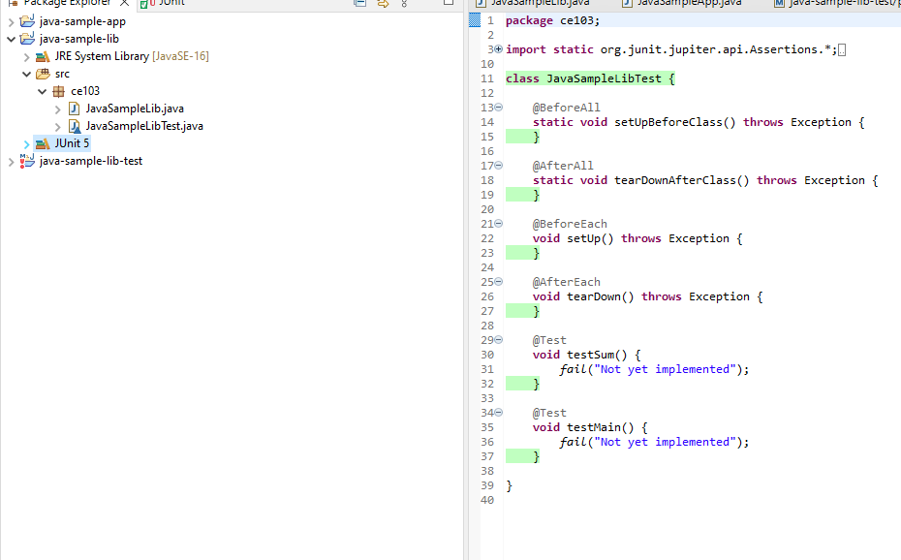

height:500px

Now we will create tests that check our function flowchart and return values

We need to cover all code branches that we coded

I have updated JavaSampleLib.java as follow to check outputs

JavaSampleLib.java

package ce103;  
  
public class JavaSampleLib {  
  
 public static String sayHelloTo(String name) {  
  
 String output = "";  
  
 if(!name.isBlank() && !name.isEmpty()){  
 output = "Hello "+name;  
 }else {  
 output = "Hello There";  
 }  
  
 System.out.println(output);  
  
 return output;  
 }  
  
 public static int sum(int a,int b)  
 {  
 int c = 0;  
 c = a+b;  
 return c;  
 }  
  
 public int multiply(int a, int b) {  
 return a * b;  
 }  
  
// public static void main(String[] args) {  
// // TODO Auto-generated method stub  
// System.out.println("Hello World!");  
//  
// JavaSampleLib.sayHelloTo("Computer");  
// int result = JavaSampleLib.sum(5, 4);  
// System.out.println("Results is" + result);  
// System.out.printf("Results is %d \n", result);  
//   
//   
// try {  
// System.in.read();  
// } catch (IOException e) {  
// // TODO Auto-generated catch block  
// e.printStackTrace();  
// }  
//  
// }  
  
}

and JavaSampleLibTest.java

package ce103;  
  
import static org.junit.jupiter.api.Assertions.*;  
  
import org.junit.jupiter.api.AfterAll;  
import org.junit.jupiter.api.AfterEach;  
import org.junit.jupiter.api.BeforeAll;  
import org.junit.jupiter.api.BeforeEach;  
import org.junit.jupiter.api.DisplayName;  
import org.junit.jupiter.api.RepeatedTest;  
import org.junit.jupiter.api.Test;  
import org.junit.jupiter.params.ParameterizedTest;  
import org.junit.jupiter.params.provider.MethodSource;  
  
class JavaSampleLibTest {  
  
 JavaSampleLib sampleLib;  
  
 @BeforeAll  
 static void setUpBeforeClass() throws Exception {  
 }  
  
 @AfterAll  
 static void tearDownAfterClass() throws Exception {  
 }  
  
 @BeforeEach  
 void setUp() throws Exception {  
 sampleLib = new JavaSampleLib();  
 }  
  
 @AfterEach  
 void tearDown() throws Exception {  
 }  
  
 @Test  
 @DisplayName("Simple Say Hello should work")  
 void testSayHelloTo() {  
 assertEquals("Hello Computer", JavaSampleLib.sayHelloTo("Computer"), "Regular say hello should work");  
 }  
  
 @Test  
 @DisplayName("Simple Say Hello shouldn' work")  
 void testSayHelloToWrong() {  
 assertEquals("Hello All", JavaSampleLib.sayHelloTo("Computer"), "Regular say hello won't work");  
 }  
  
  
 @Test  
 @DisplayName("Simple sum should work")  
 void testSumCorrect() {  
 assertEquals(9, JavaSampleLib.sum(4, 5), "Regular sum should work");  
 }  
  
 @Test  
 @DisplayName("Simple sum shouldn't work")  
 void testSumWrong() {  
 assertEquals(10, JavaSampleLib.sum(4, 5), "Regular sum shouldn't work");  
 }  
  
 @Test  
 @DisplayName("Simple multiplication should work")  
 void testMultiply() {  
 assertEquals(20, sampleLib.multiply(4, 5), "Regular multiplication should work");  
 }  
  
 @RepeatedTest(5)  
 @DisplayName("Ensure correct handling of zero")  
 void testMultiplyWithZero() {  
 assertEquals(0, sampleLib.multiply(0, 5), "Multiple with zero should be zero");  
 assertEquals(0, sampleLib.multiply(5, 0), "Multiple with zero should be zero");  
 }  
  
 public static int[][] data() {  
 return new int[][] { { 1, 2, 2 }, { 5, 3, 15 }, { 121, 4, 484 },{ 2, 2, 2 } };  
 }  
  
 @ParameterizedTest  
 @MethodSource(value = "data")  
 void testWithStringParameter(int[] data) {  
 JavaSampleLib tester = new JavaSampleLib();  
 int m1 = data[0];  
 int m2 = data[1];  
 int expected = data[2];  
 assertEquals(expected, tester.multiply(m1, m2));  
 }  
  
}

if we run tests

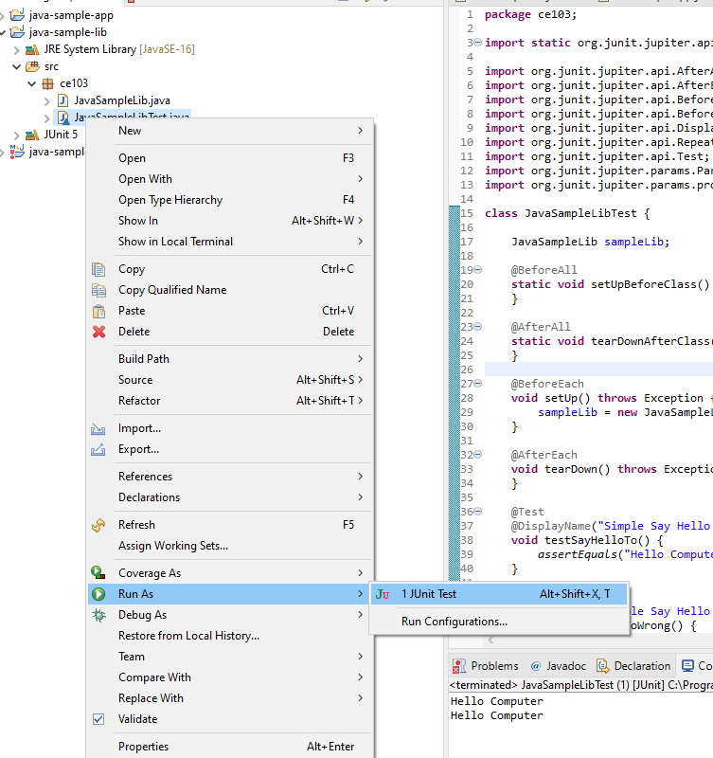

height:500px

we will see all results there

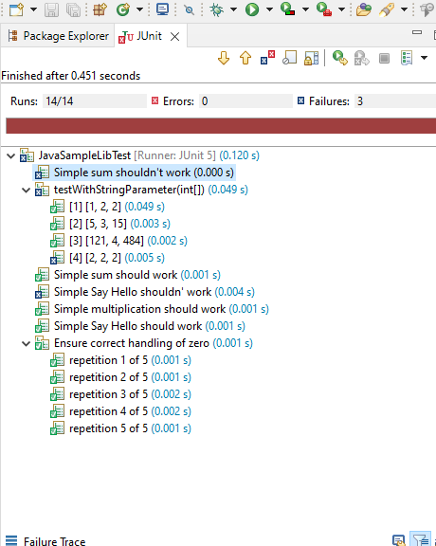

height:500px

also we can see the code coverage of tests

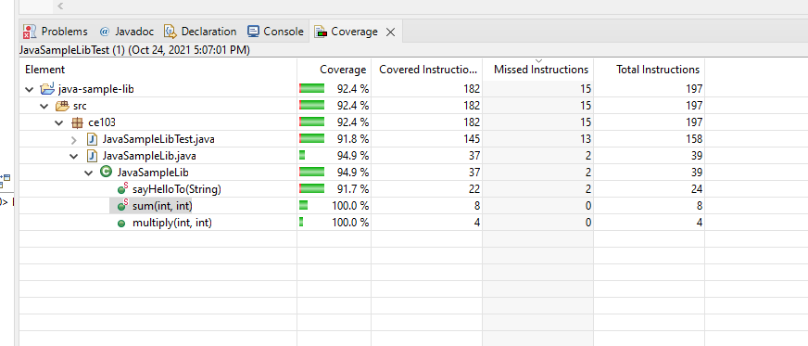

height:500px

when we open our source code (just close and open again another case highlighting will not work) you will see tested part of your codes

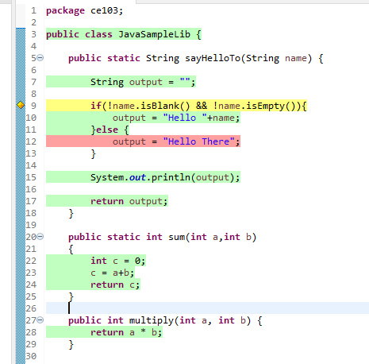

height:500px

#### Maven Java Application + JUnit

Lets create Maven project with tests

Create a maven project

*File -> New -> Maven Project*

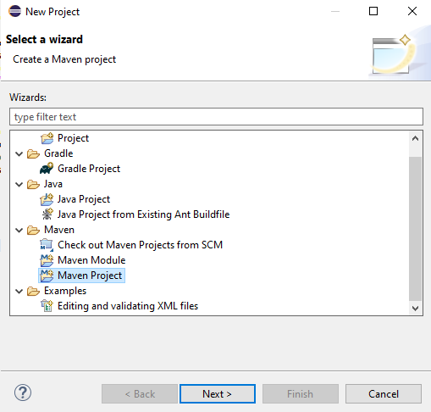

height:500px

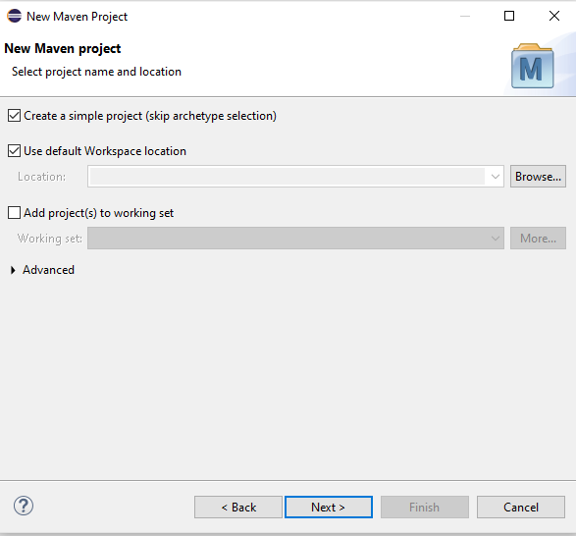

height:500px

Lets convert our sample java-sample-lib directories to standard folder structure for test and app division

[Maven – Introduction to the Standard Directory Layout](http://maven.apache.org/guides/introduction/introduction-to-the-standard-directory-layout.html)

Also for intro you can use this

[JUnit Hello World Example - Examples Java Code Geeks - 2021](https://examples.javacodegeeks.com/core-java/junit/junit-hello-world-example/)

Eclipse  
Maven  
Java  
JUnit 4.12 (pulled by Maven automatically)

Lets give new sample java-sample-lib-mvnbut in this time we will create a maven project

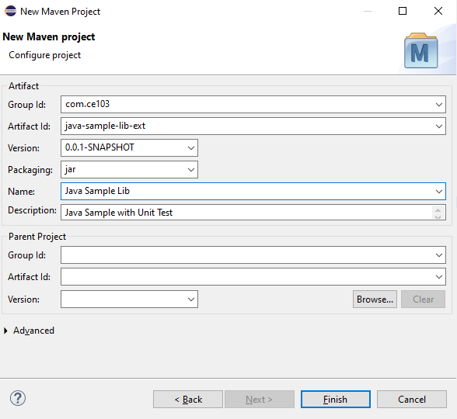

height:500px

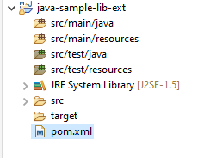

height:500px

pom.xml file

<project xmlns="http://maven.apache.org/POM/4.0.0" xmlns:xsi="http://www.w3.org/2001/XMLSchema-instance" xsi:schemaLocation="http://maven.apache.org/POM/4.0.0 https://maven.apache.org/xsd/maven-4.0.0.xsd">  
 <modelVersion>4.0.0</modelVersion>  
 <groupId>com.ce103</groupId>  
 <artifactId>java-sample-lib-ext</artifactId>  
 <version>0.0.1-SNAPSHOT</version>  
 <name>Java Sample Lib</name>  
 <description>Java Sample with Unit Test</description>  
</project>

we will add JUnit 5 for our project

<project xmlns="http://maven.apache.org/POM/4.0.0"  
 xmlns:xsi="http://www.w3.org/2001/XMLSchema-instance"  
 xsi:schemaLocation="http://maven.apache.org/POM/4.0.0 https://maven.apache.org/xsd/maven-4.0.0.xsd">  
 <modelVersion>4.0.0</modelVersion>  
 <groupId>com.ce103</groupId>  
 <artifactId>java-sample-lib-ext</artifactId>  
 <version>0.0.1-SNAPSHOT</version>  
 <name>Java Sample Lib</name>  
 <description>Java Sample with Unit Test</description>  
  
 <dependencies>  
 <dependency>  
 <groupId>org.junit.jupiter</groupId>  
 <artifactId>junit-jupiter-params</artifactId>  
 <version>5.7.1</version>  
 <scope>test</scope>  
 </dependency>  
 </dependencies>  
  
</project>

it will automatically download libraries

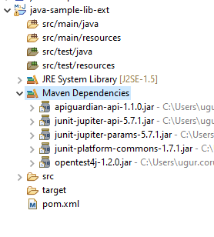

height:500px

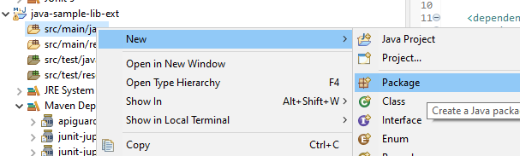

height:500px

Create java sample library in ce103 package, first create java package

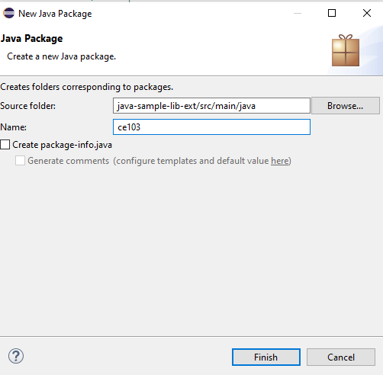

height:500px

In this package create library class

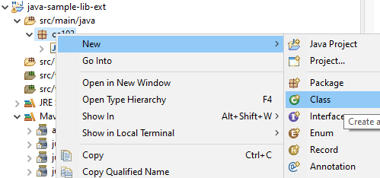

height:500px

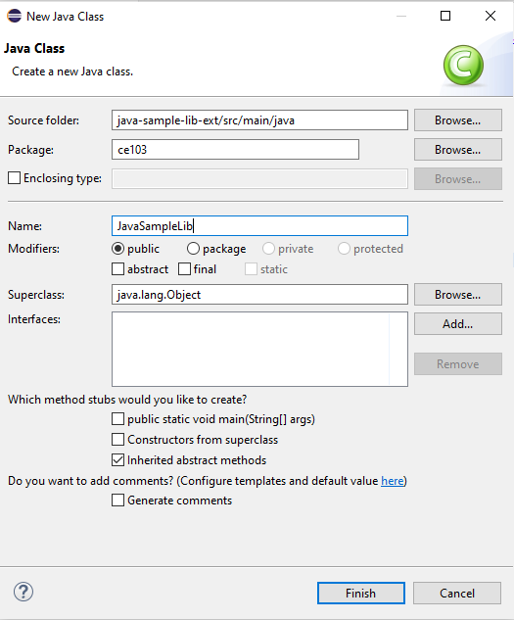

height:500px

copy content from other library

package ce103;  
  
public class JavaSampleLib {  
  
public static String sayHelloTo(String name) {  
  
 String output = "";  
  
 if(!name.isBlank() && !name.isEmpty()){  
 output = "Hello "+name;  
 }else {  
 output = "Hello There";  
 }  
  
 System.out.println(output);  
  
 return output;  
 }  
  
 public static int sum(int a,int b)  
 {  
 int c = 0;  
 c = a+b;  
 return c;  
 }  
  
 public int multiply(int a, int b) {  
 return a * b;  
 }  
  
  
}

Now lets create tests inf src/test/java

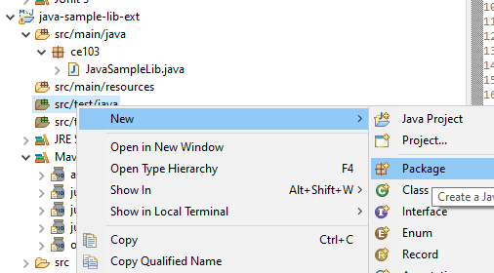

height:500px

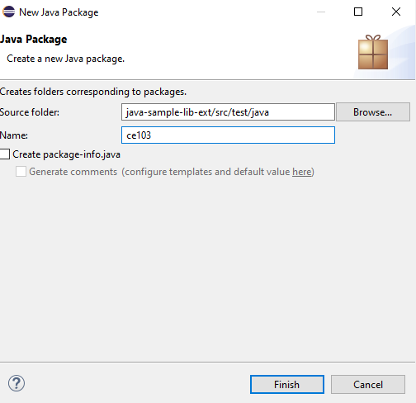

height:500px

create a JUnit Case

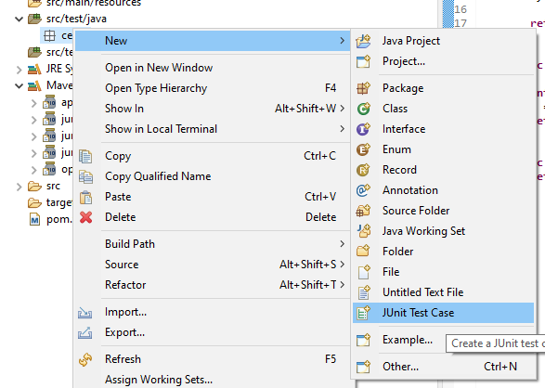

height:500px

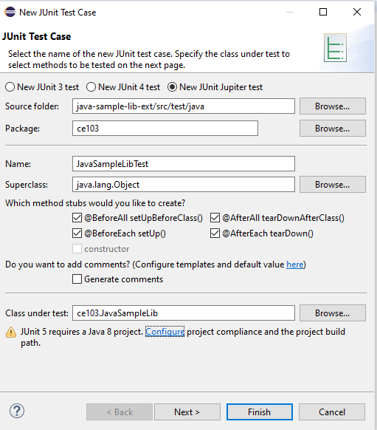

height:500px

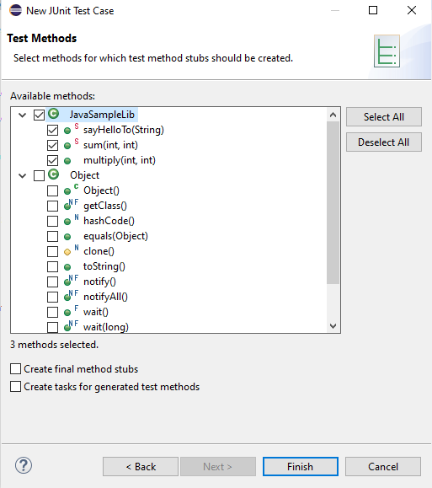

height:500px

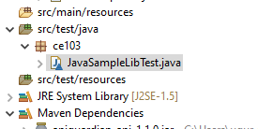

height:500px

you will simple template

package ce103;  
  
import static org.junit.jupiter.api.Assertions.*;  
  
import org.junit.jupiter.api.AfterAll;  
import org.junit.jupiter.api.AfterEach;  
import org.junit.jupiter.api.BeforeAll;  
import org.junit.jupiter.api.BeforeEach;  
import org.junit.jupiter.api.Test;  
  
class JavaSampleLibTest {  
  
 @BeforeAll  
 static void setUpBeforeClass() throws Exception {  
 }  
  
 @AfterAll  
 static void tearDownAfterClass() throws Exception {  
 }  
  
 @BeforeEach  
 void setUp() throws Exception {  
 }  
  
 @AfterEach  
 void tearDown() throws Exception {  
 }  
  
 @Test  
 void testSayHelloTo() {  
 fail("Not yet implemented");  
 }  
  
 @Test  
 void testSum() {  
 fail("Not yet implemented");  
 }  
  
 @Test  
 void testMultiply() {  
 fail("Not yet implemented");  
 }  
  
}

now lets copy tests from other projects

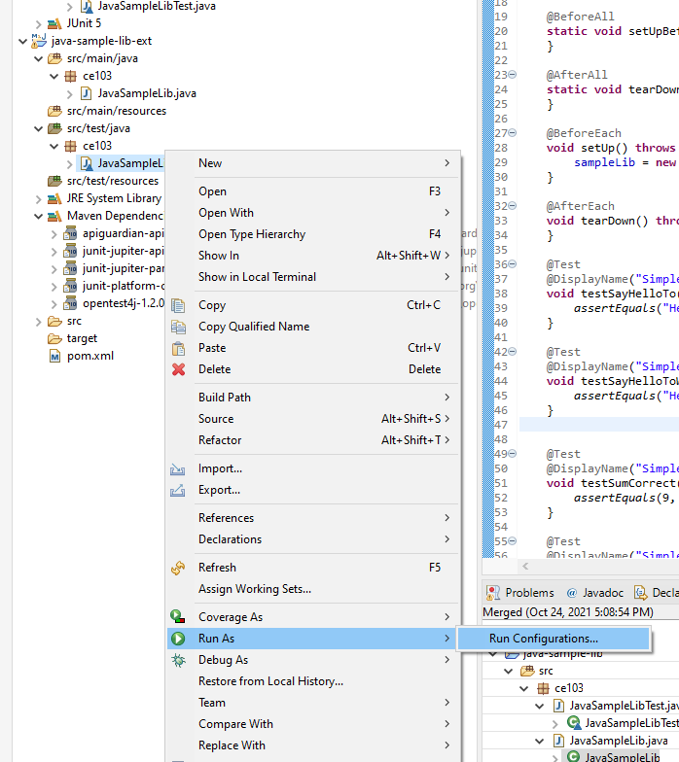

height:500px

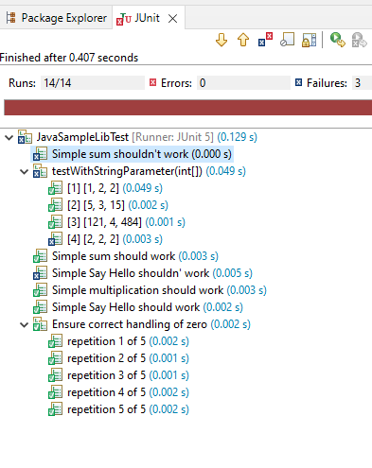

height:500px

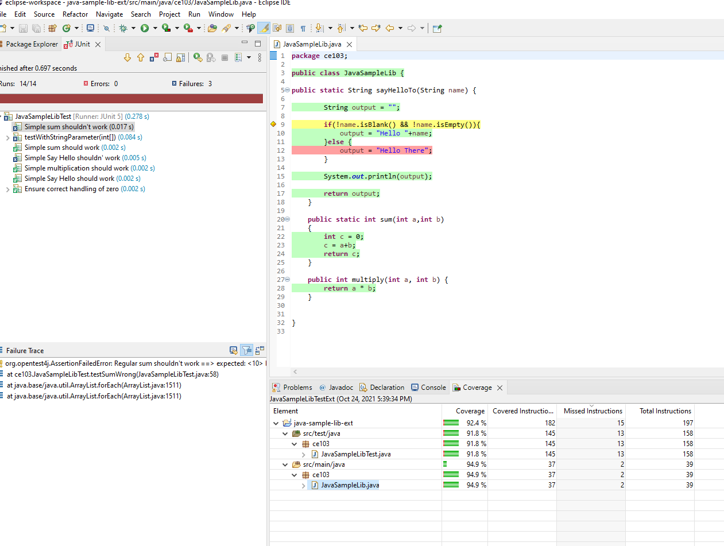

height:500px

That’s a part of java unit testing…

## TDD (Test Driven Development)

## Test and Deployment Automation Management

#### Travis-CI + C

#### Travis-CI + Cpp

#### Travis-CI + C

#### Travis-CI + Java

# References

[GitHub - MicrosoftDocs/cpp-docs: C++ Documentation](https://github.com/MicrosoftDocs/cpp-docs)